**The Effect of Personality and Motivation on Employee Performance Through Citizenship Behavior Organizational Variables At Bank Sulselbar Makassar Main Branch**

Rizki Muthia Pulubuhu1, Sumardi 2, Maat Pono 3

1,2,3 Universitas Hasanuddin

# Abstract

This study aims to analyze the influence of personality, motivation and organizational citizenship behavior (OCB) on employee performance at Bank Sulselbar Makassar Main Branch, either directly or indirectly (mediation effect). This study was conducted to examine and analyze the influence of Personality and Motivation on Employee Performance through Organizational Citizenship Behavior Variables at Bank Sulselbar Main Branch Makassar by placing personality and motivation as independent variables and Organizational Citizenship Behavior (OCB) and employee performance as dependent variables. Based on the objectives to be achieved, this research is included in the category of explanatory research, namely research conducted by identifying facts and events that arise from the object under study. The results showed that partially personality and motivation had a significant effect on OCB and employee performance. Furthermore, for the indirect effect, empirical facts are found that OCB can be a mediating variable for the indirect effect of personality and motivation on employee performance significantly.

**Keywords:** Personality, Motivation, OCB, Employee Performance

# INTRODUCTION

Banks as one of the businesses engaged in financial services, really need the support of professional human resources in carrying out their activities. In addition, banks are increasingly required to provide the latest facilities and technology in providing financial services to their customers. The increasing importance of the role of human resources and the support of facilities and technology in the banking business is caused by the tendency of increasingly fierce competition between banks in capturing customers, as a result of the rapid growth of the banking business, especially in Makassar City.

In an increasingly competitive business competition accompanied by very dynamic environmental changes, it is imperative that every company, including the banking business, has professional and reliable human resources. Therefore, banks must make their human resources as core competencies in managing their business, in order to be able to compete and exist in business competition through the creation and improvement of employee performance; and high employee performance can not be separated from the human resource management model implemented by the company (Permana 2019).

Performance reflects how well employees meet the requirements of a job, and reflects the effectiveness of leaders in improving employee performance. Individual employee performance is an achievement achieved by a person in a certain period. Increased employee performance will not happen by itself, without certain preconditions. Efforts to improve employee performance require commitment, determination and continuous efforts from all parties in the organization to improve. Better management and development of human resources will provide benefits for the organization, in addition to increasing work efficiency to save costs, improve performance, accelerate the process of achieving goals, will also create good relationships and loyalty between employees and the organization (Kusuma 2016).

PT. Bank Sulselbar is a Regional Development Bank where as a Regional Bank, of course, the shareholders have high hopes for this Bank to be a pioneer in the region. Bank Sulselbar Makassar Main Branch of course has a very big role in this case as the largest branch with a larger number of customers and employees than other branches, of course, will be the role of other branches. With a larger number of employees and customers, of course, the more types of characters faced, and the greater the duties and responsibilities of the employees at the Makassar Main Branch.

Based on this, it can be seen that the workload of the employees at the Makassar Main Branch is greater than that of several other branches. Therefore, Organizational Citizenship Behavior (OCB) must be owned by employees at Bank Sulselbar Makassar Main Branch. By having Organizational Citizenship Behavior (OCB) values, employees will voluntarily help their colleagues and superiors in solving problems and assisting the organization in achieving its goals, employees will be present on time at the office, not leaving the office during working hours, even willing to work outside working hours voluntarily.

The condition of the employees at Bank Sulselbar Makassar Main Branch in carrying out their duties is still not optimal, marked by still having administrative tasks that are often delayed, there are still many employees who are not present on time, there are still employees who leave the office during working hours, not all employees are willing to work outside working hours voluntarily, also the lack of mutual assistance to complete tasks quickly and accurately, as well as not being consistent in carrying out service SOPs for front office employees. These things grow, of course, due to factors within the employee or by organizational environmental factors.

Based on the description of the background above, the authors are interested in conducting research with the title "The Influence of Personality and Motivation on Employee Performance Through Organizational Citizenship Behavior Variables at Bank Sulselbar Makassar Main Branch".

**Personality**

Personality is a dynamic arrangement that is hidden within a person which is a system that will create an array of characteristics of a person's behavior, thoughts, and feelings (Widyasari, Syahlani, and Santosa 2017). Meanwhile, according to Daft (2014: 293), personality is a set of characteristics that underlie relatively stable behavior patterns in responding to ideas, objects, or people in the environment.

**Motivation**

Robbin in research Rahayu dan Ruhamak (2017) argues that motivation is "The desire to do something as a willingness to expend a high level of effort for organizational goals, conditioned by the ability of that effort to meet an individual need. Meanwhile, according to Hasibuan in Hutabarat's research (2019) that motivation is a way of directing the power and potential of subordinates, so that they want to work together productively and successfully and realize the goals that have been determined.

**Organizational Citizenship Behaviour**

Organizational Citizenship Behavior according to Purnamie (2014: 6), OCB is employee behavior that is not visible to co-workers or to the company, where the behavior exceeds the standard behavior set by the company and provides benefits to the company. Based on this definition, it can be concluded that OCB is an individual contribution made based on one's own desires that exceeds the work standards that have been set so that it can provide benefits to the work environment.

**Employee Performance**

Employee performance is said to be good if all the indicators that influence it are good too. The employee performance indicators are quantity, quality, employee reliability, and employee attendance. Quantity is the amount of work that a person can do in one working day. Quality is the obedience of employees according to procedures, discipline, and dedication to the organization. Employee reliability is the ability of employees to carry out work that includes consistency in performance and reliability in service, accurate, correct, and precise (Pasaribu and Indrawati 2016). Meanwhile, according to Mangkunegara (2006:67), performance is the result of work in quality and quantity achieved by a person in carrying out his duties in accordance with the responsibilities given to him.

**Conceptual Framework**

This study will empirically examine how far the influence of personality and motivation on Organizational Citizenship Behavior (OCB) and employee performance at Bank Sulselbar Makassar Main Branch. Personality and organizational motivation respectively as independent variables and Organizational Citizenship Behavior (OCB) and employee performance as dependent variables

Figure 1

Conceptual Framework



# LITERATURE REVIEW

1. **Personality**

Personality is a dynamic arrangement that is hidden within a person which is a system that will create an array of characteristics of a person's behavior, thoughts, and feelings (Widyasari, Syahlani, and Santosa 2017). Meanwhile, according to Daft (2014: 293), personality is a set of characteristics that underlie relatively stable behavior patterns in responding to ideas, objects, or people in the environment.

1. **Motivation**

Robbin in research Rahayu dan Ruhamak (2017) argues that motivation is "The desire to do something as a willingness to expend a high level of effort for organizational goals, conditioned by the ability of that effort to meet an individual need. Meanwhile, according to Hasibuan in Hutabarat's research (2019) that motivation is a way of directing the power and potential of subordinates, so that they want to work together productively and successfully and realize the goals that have been determined.

1. **Organizational Citizenship Behaviour**

Organizational Citizenship Behavior according to Purnamie (2014: 6), OCB is employee behavior that is not visible to co-workers or to the company, where the behavior exceeds the standard behavior set by the company and provides benefits to the company. Based on this definition, it can be concluded that OCB is an individual contribution made based on one's own desires that exceeds the work standards that have been set so that it can provide benefits to the work environment.

1. **Employee Performance**

Employee performance is said to be good if all the indicators that influence it are good too. The employee performance indicators are quantity, quality, employee reliability, and employee attendance. Quantity is the amount of work that a person can do in one working day. Quality is the obedience of employees according to procedures, discipline, and dedication to the organization. Employee reliability is the ability of employees to carry out work that includes consistency in performance and reliability in service, accurate, correct, and precise (Pasaribu and Indrawati 2016). Meanwhile, according to Mangkunegara (2006:67), performance is the result of work in quality and quantity achieved by a person in carrying out his duties in accordance with the responsibilities given to him.

1. **Conceptual Framework**

This study will empirically examine how far the influence of personality and motivation on Organizational Citizenship Behavior (OCB) and employee performance at Bank Sulselbar Makassar Main Branch. Personality and organizational motivation respectively as independent variables and Organizational Citizenship Behavior (OCB) and employee performance as dependent variables

Figure 1

Conceptual Framework



# RESEARCH METHOD

# Research Type and Design

This research is included in the category of explanatory research, namely research conducted by identifying facts and events that arise from the object under study.

# Research sites

This research was carried out at Bank Sulselbar Makassar Main Branch at Street. Dr. Ratulangi No. 16 Mariso District, Makassar City, South Sulawesi. The choice of research location was based on the ease with which researchers obtained primary data.

# Population and Sample

The population in this study were all staff employees at Bank Sulselbar Makassar Main Branch totaling 107 people. There are 75 permanent employees and 32 contract employees.

# Data Analysis Technique

The data were analyzed using descriptive analysis, data quality test, hypothesis testing, differentiation model test (R2) and path analysis (Path Analysis).

# RESEARCH RESULT

**Validity Test**

From the results of validity testing, the questionnaire containing these 4 variables contained 18 questions that had been filled out by 107 respondents in this study. From the results of the calculation of validity, it can be seen that each question from each variable shows the value of r count > r table = 0.30. So that the results of the validity test on all questions from each variable are valid.

**Reliability Test**

Based on the results of processing using SPSS version 21. Cronbach's Alpha for all variables which can be seen in the following table:

Tabel 1

Reliability Test Results

|  |  |  |
| --- | --- | --- |
| **Variable** | **Cronbach’s Alpha** | **Description** |
| Personality (X1) | 0.848 | Reliable |
| Motivation (X2) | 0.791 | Reliable |
| OCB (Y1) | 0.846 | Reliable |
| Employe Performance (Y2) | 0.798 | Reliable |

Based on the table above, it can be seen that each variable between Personality (X1), Motivation (X2), OCB (Y1), Employee Performance (Y2) variables was obtained Cronbach Alpha value 0.60. Thus, the results of the reliability test on all variables are reliable.

**Hypothesis Test**

**Direct Effect Hypothesis Test**

**Path Analysis I**

Table 2

Regression Model

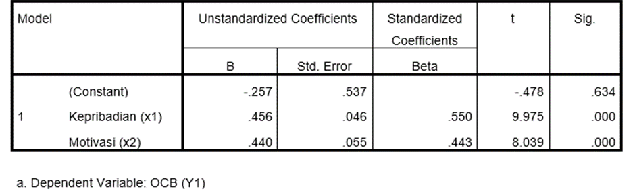

Based on the regression equation, it shows that the personality and motivation variables have a positive regression coefficient direction with OCB, this shows that the personality and motivation variables will have a positive influence on OCB.

**Coefficient of Determination**

Table 3

Determination Test

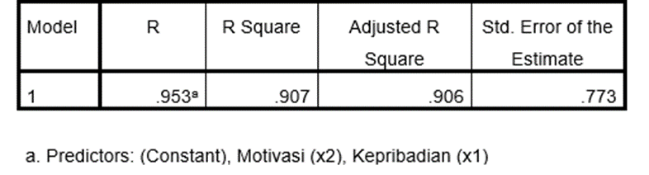

Based on the determination test of the value of R Square that is equal to 0.907, which means that the personality and motivation variables can explain the OCB variable by 90.7% and the remaining 9.3% which are other variables not examined in this study.

**Path Analysis II**

Table 4

Regression Model

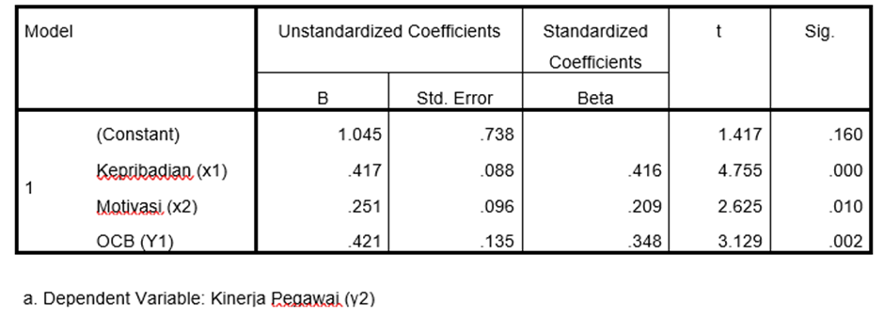

Based on the regression equation, it shows that the variables of personality, motivation and OCB have a positive regression coefficient direction or are directly proportional to employee performance, this shows that the variables of personality, motivation and OCB will have a positive influence on employee performance.

**Coefficient of Determination**

Table 5

Determination Test

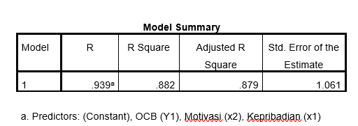

Based on table 5 above, it shows the test of determination from the value of R Square that is equal to 0.882 which means the personality variable, motivation and OCB explain employee performance variables by 88.2% and the remaining 11.8% which are other variables not examined in this study. Meanwhile, the value of e2 can be found with the formula e2 = 1-0,882 = 0.34.

**Indirect Effect Hypothesis Test**

The indirect effect test uses the Sobel test calculation. The following is the Sobel test calculation using the Sobel test calculator:

1. The influence of personality on the performance of employees of Sulsebar Makassar Main Branch through Organizational Citizenship Behavior (OCB).

Table 6

Sobel Test Calculator Results

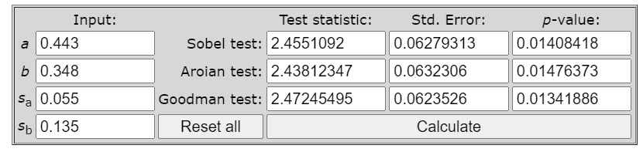

Source: Sobel Test Calculator processed data (https://www. <http://quantpsy.org/>)

Based on table 6 above, it is known that the influence of personality on employee performance through OCB as a moderating variable is shown by the t-statistic value of 2,519 which is greater than the t-table of 1.98. This means that the hypothesis is accepted. Which shows that personality has a positive and significant effect on employee performance through OCB.

1. The influence of motivation on the performance of employees of Sulsebar Makassar Main Branch through Organizational Citizenship Behavior (OCB).

Table 7

Sobel Test Calculator Results



Source: Sobel Test Calculator processed data (https://www. http://quantpsy.org/)

Based on table 7 above, it is known that the effect of motivation on employee performance through OCB as a moderating variable is shown by the t-statistic value of 2.455 which is greater than the t-table of 1.98. This means that the hypothesis is accepted. Which shows that motivation has a positive and significant effect on employee performance through OCB.

Based on the results of the analysis of direct and indirect effects in the previous section, the coefficient values and significance levels can be described in table 8 below:

Table 8

Hypothesis Test Results

|  |  |  |  |  |
| --- | --- | --- | --- | --- |
|  | Beta  (Coefficient) | T Hitung | Sig | Description |
| Personality => OCB | 0.550 | 9.975 | 0.000 | Positive and Significant |
| Motivation => OCB | 0.443 | 8.039 | 0.000 | Positive and Significant |
| Personality => Employe Performance | 0.416 | 4.755 | 0.000 | Positive and Significant |
| Motivation => Employe Performance | 0.209 | 2.625 | 0.010 | Positive and Significant |
| OCB => Employe Performance | 0.348 | 3.129 | 0.002 | Positive and Significant |
| Personality => OCB => Employe Performance | 0.191 | 2.519 | 0.012 | Positive and Significant |
| Motivation => OCB => Employe Performance | 0.154 | 2.455 | 0.014 | Positive and Significant |

***Source: Data Processing (2021)***

# DISCUSSION

**Effect of CRM on Customer Satisfaction**

Based on the results of the previous table, it can be seen the influence of personality and motivation on employee performance through organizational citizenship behavior variables at Bank Sulselbar Makassar main branch as follows:

1. Influence of Personality on Organizational Citizenship Behavior (OCB) at Bank Sulsebar Makassar Main Branch.

The results showed that the better the personality, the better the Organizational Citizenship Behavior (OCB). Based on the results of a questionnaire to several employees of Bank Sulselbar Makassar Main Branch said that for personality related to Organizational Citizenship Behavior (OCB). Shows that personality is good enough and needs to be improved again so that Organizational Citizenship Behavior (OCB) can increase further. It has been shown that some people who show who they are or how they show their personality are more likely to show them OCB. In addition, Personality is a variable forming Organizational Citizenship Behavior (OCB).

1. The Influence of Personality on the Performance of Employees of Sulsebar Makassar Main Branch

The results of the study show that personality on the performance of employees of South Sulawesi Main Branch Makassar has a positive and significant effect. Based on the results of questionnaires to several employees of Bank Sulselbar Makassar Main Branch said that for personality related to the performance of employees of South Sulawesi Main Branch Makassar. Shows that the personality is good enough and needs to be improved again so that the performance of the employees of Sulselbar Makassar Main Branch is further improved.

1. The Effect of Motivation on Organizational Citizenship Behavior (OCB) in Sulsebar, Makassar Main Branch.

The results showed that if motivation was increased, it would have an effect on increasing Organizational Citizenship Behavior (OCB). The results also show respondents' responses about motivation to Organizational Citizenship Behavior (OCB) which shows the average respondent's response is high/good although there are still those who show a doubtful and disagree response to Organizational Citizenship Behavior (OCB). Based on the results of a questionnaire to several employees of Bank Sulselbar Makassar Main Branch said that for motivation related to Organizational Citizenship Behavior (OCB). Shows that when motivation is increased, it will affect Organizational Citizenship Behavior (OCB).

1. The Influence of Motivation on Employee Performance in Sulsebar Makassar Main Branch.

The results of the study show that motivation on the performance of employees of South Sulawesi Main Branch Makassar has a positive and significant effect. Based on the results of distributing questionnaires to several employees of Bank Sulselbar Makassar Main Branch said that for motivation related to the performance of employees of South Sulawesi Main Branch Makassar. Shows that motivation is good enough and needs to be improved again so that the performance of the employees of South Sulawesi Main Branch Makassar can increase. Motivation to an employee is needed to improve his performance. Motivation must be created as well as possible so that employees can be passionate about work so that employees can contribute all thoughts, abilities, and skills to realize the goals of employees to be achieved.

1. Effect of Organizational Citizenship Behavior (OCB) on Employee Performance at Bank Sulsebar Makassar Main Branch.

The results showed that the better Organizational Citizenship Behavior (OCB), the better the employee's performance. The results also show respondents' responses about Organizational Citizenship Behavior (OCB) on employee performance, which shows the average respondent's response is high/good although there are still those who show a doubtful and disagreed response to the employee's current perceived performance of Organizational Citizenship Behavior (OCB). Based on the results of the distribution of questionnaires to several employees of Bank Sulsebar Makassar Main Branch said that for Organizational Citizenship Behavior (OCB) it shows that employee performance is quite good and needs to be improved again so that Organizational Citizenship Behavior (OCB) is further improved.

1. The Influence of Personality on Employee Performance in Sulsebar Makassar Main Branch through Organizational Citizenship Behavior (OCB).

Personality shows a positive and significant influence on employee performance if mediated by organizational citizenship behavior (OCB), which means that when an employee's personality is further improved in a positive way, it will affect individual contributions that exceed the demands of the role in the workplace which will have implications for increasing employee performance overall significant. This OCB involves several behaviors including helping others, working without having to complain, maintaining good relations with work colleague. These behaviors illustrate the added value of employees so that the organization can run effectively.

1. The Influence of Motivation on Employee Performance in Sulsebar Makassar Main Branch through Organizational Citizenship Behavior (OCB).

Motivation shows a positive and significant effect on employee performance if it is mediated by organizational citizenship behavior (OCB), which means that when an employee's motivation is increased, it will affect the individual contribution that exceeds the demands of the role in the workplace which will have implications for increasing employee performance significantly. This can also be seen from the respondents' responses regarding the three variables which generally gave a good response or assessment.

# CONCLUSION

Based on the results of research on the influence of personality and motivation on employee performance through organizational citizenship behavior variables at the Makassar Bank Sulselbar main branch, it can be concluded as follows:

Personality has a positive and significant effect on OCB, which means that when an employee always maintains or improves his personality in a more positive direction, it will have an impact on the creation of a good organizational citizenship behavior climate. While motivation has a positive and significant effect on OCB, which means that when an employee increases motivation at work, it will have an impact on the creation of a good organizational citizenship behavior climate.

Personality has a positive and significant effect on employee performance, which means that when an employee always maintains or improves his personality in a more positive direction, it will have an impact on improving performance. While motivation has a positive and significant effect on employee performance, which means that when an employee increases motivation at work, it will have an impact on the creation of optimization of employee performance.

Organizational citizenship behavior has a positive and significant effect on employee performance, which means that when an employee is increasingly maintaining organizational citizenship behavior at work, it will have an impact on increasing employee performance.

Personality has a positive and significant effect on employee performance if mediated by OCB, which means when an employee always maintains or improves his personality in a more positive direction, it will have an impact on the creation of an OCB climate that can support increased performance. While motivation has a positive and significant effect on employee performance if it is mediated by OCB, which means when an employee increases motivation at work, it will have an impact on the creation of good OCB which can also improve employee performance.

Suggestions for PT Bank Sulselbar Makassar main branch is to maintain and support efforts to improve the personality of employees in a more positive and work-oriented direction by paying more attention to the suitability of giving job desks to employees. In addition, maintaining employee motivation by providing opportunities for capacity development to support the work of its employees. And, maintain organizational citizenship behavior that supports employee performance by paying more attention to employees so that they always tolerate less than ideal conditions in the organization.

# REFERENCE

Daft, Richard L. 2014a. New Era of Management. Edition 4. Jakarta: Salemba Empat.

Hutabarat, Lolasari Novelly. 2019. “The Influence of Supervision, Organizational Culture and Remuneration on Employee Work Motivation.” Maneggio: Scientific Journal of Masters in Management 2 (2): 200–213. Https://Doi.Org/10.30596/Maneggio.V2i2.3777.

Kusuma, C R. 2016. "The Influence of Leadership, Motivation, Incentives and Islamic Work Ethic on the Performance of BNI Syariah Employees in Semarang Branch," No. Thesis: Islamic Banking, Faculty of Economics & Other Business.

Mangkunegara, A. A. (2002). Human Resource Management. Bandung: PT. Rosdakarya Youth.

Pasaribu, Evan Karno, And Ayu Desi Indrawati. 2016. “The Influence of Organizational Climate and Quality of Work Life on the Performance of Bali Provincial Social Service Employees” 5 (12): 7785–7809.

Purnamie, T. 2014. The Role of Organizational Citizenship Behavior (OCB). Jakarta: Wicana Media Partners

Permana, Estu. 2019. “Strategy Analysis of Human Resource Development and Sharia Insurance Products in Increasing Competitive Advantage (Study at Pt. Sharia Life Insurance Al Amin Bandar Lampung).” Carbohydrate Polymers. Raden Intan State Islamic University, Lampung.

Rahayu, Budi, And M Dian Ruhamak. 2017. “The Influence of Leadership, Incentives, Remuneration and Motivation on Employee Performance (Case Study At Pt Industri Sandang Pangan Nusantara Cilacap).” Ekonika: Journal of Economics, University of Kadiri 2 (1): 1–22. [Https://Doi.Org/10.30737/Ekonika.V2i1.15](https://doi.org/10.30737/Ekonika.V2i1.15).

Widyasari, Ratna, Suci Paramitasari Syahlani, and Krishna Agung Santosa. 2017. “The Influence of Personality on the Performance of Highly Educated Employees: Analysis of Livestock Companies in Central Java and the Special Region of Yogyakarta.” Performance 11(1): 40–49.