Some Characteristics of Atmospheric Boundary Layer over Makassar

Submitted: January 14, 2018, Accepted: February 19, 2018

Abstract.

Some upper-air atmospheric parameters measured from 2011 to 2016 using radiosonde located at Hasanuddin International Airport were examined for characterization of the boundary layer over Makassar, Indonesia. These data, combined with surface atmospheric parameters, were used to calculate some boundary layer parameters using AERMET model which based on Monin-Obukhov similarity theory. The obtained Monin-Obukhov length which reflecting atmospheric stability then converted into traditional Pasquill-Gifford stability classification. Examination of wind characteristics of wind showing clearly their dependence of the day, season, and height. Winds dominantly flow from the southeast during the daytime with the relatively larger velocity and from the northwest with smaller velocity during the nighttime. Interpretation of Monin-Obukhov length using Pasquill-Gifford stability classification showing that the atmosphere was dominantly unstable during the daytime and dominantly stable during the nighttime. These atmospheric stabilities were also varied during seasons. The height of the convective boundary layer (CBL) was starting to rise in the morning and reaching its maximum in the afternoon (18:00) at the mean value of 2 km. Meanwhile, the height of the mechanical boundary layer (MBL) during the day time, forming a parabolic curve with its maximum value of 1.2 km at noon. These indicated that any released pollution from the stack would be less dispersed during the nighttime due to the fact of lower mixing height, lower wind speed, the atmosphere becomes more stable, and it dispersed in a different direction compared to the daytime.

Keywords: atmospheric boundary layer, atmospheric stability, AERMET, boundary layer height

Introduction

Study on atmospheric boundary layer plays important role in air quality modeling. Information about mixing height, atmospheric stability, wind profile, and turbulence characteristics will be valuable in predicting the behavior of air pollutant dispersion. The wind will determine the direction and the speed of pollutant away from its source. The atmospheric turbulence will determine the turbulence dispersion. The temperature affects the rise of a buoyant plume (Stull, 1988, 2017; AERMOD, 1988a).

Preparation of meteorological data for air quality modeling is one of the important steps that challenging for development country, such as Indonesia. The data can be obtained from satellite, global model, or surface station. The satellite can cover the whole globe, but its resolution is too coarse to be used in the short-range model. Another choice is to use the global meteorological model, such as MM5 or WRF (Assegaf et al., 2015; Grell et al., 1994; Jayadipraja et al., 2016; Jesse et al., 2011). We start from the coarse grid, then downscaling at the area of interest. Preparation of the model for generating long term prediction (in the order of 5 years or more) required huge computer resource and some detail of parameters setting need advance expertise. The best data is from the measurement at the local surface station. Unfortunately, the availability of surface meteorological station, that provide upper air meteorological profile data is very few in the developing country, such as Indonesia. Until recently, some major airports in Indonesia are equipped with radiosonde to measure the meteorological profile around the airport.

This paper describes the preparation of meteorological data based on the local station. Both surface and upper meteorological data were processed to obtain boundary layer parameters such as sensible heat flux, friction velocity, convective velocity scale, boundary layer height, as well as Monin-Obukhov length (L) (Monin and Obukhov, 1954).

MATERIALS AND METHODS

Location and Data Preparation

The data was measured at Hasanuddin International Airport, Makassar, Indonesia (WMO station code: 971800) located at (5.080553S, 119.551243E) can be seen in Figure 1. The data period of 2011-2016 covering 336,525 records of surface and upper-air data was used. The upper air data was taken four times a day at 00:00, 06:00, 12:00, and 18:00 local standard time (LST). It consists of height of measurement (m), temperature (0C), dew point temperature (0C), pressure (mbar), wind velocity (m/s) and direction (degree) at correspondence height. In this study, we only use profile data at a significant level (code 5 at FSL file). The hourly surface data consists of station pressure (mbar), surface temperature (0C), dew point temperature (0C), surface wind velocity (m/s) and direction (degree), and sky cover. The measurement was taken at 30 m above mean sea level. The portion of missing data is less than 2%.

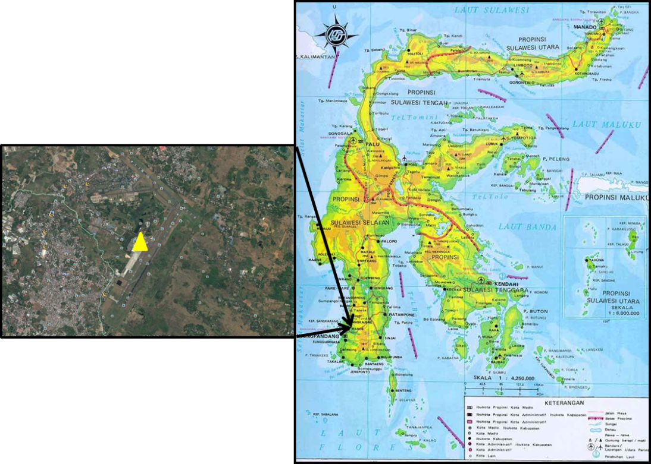

Figure 1. Location map of Sultan Hasanuddin International Airport (inset on map)

AERMET Model

The AERMET model is a meteorological processor for the AERMOD model (Cimorelli et al., 2005; AERMOD, 1998a), together with AERSURFACE model (as a terrain/morphology processor) (Perry et.al., 2005; AERMOD, 1998b). AERMOD system is regulated model in USA, Canada, and some European countries. It utilizes the principle of surface heat equilibrium to calculate friction velocity, convective velocity scale, as well as Monin-Obukhov length (L) (Monin and Obukhov, 1954) and determine whether the atmosphere is stable or unstable. A planetary boundary layer (PBL) is divided into two types: the convective boundary layer (CBL) and stable boundary layer (SBL). CBL is developed during the day. It is driving by surface heating and can cause moderate to strong vertical mixing (Stull, 1988). Meanwhile, SBL develops at night, driven by surface cooling and causing little to no vertical mixing. In calculating the transfer of surface heat to the atmosphere and vice versa, AERMET refers to the formula proposed (Holtslag and Ulden, 1983; Holtslag and Bruin, 1988; Ulden and Holtslag, 1985), which calculated the solar radiation flux as a function of temperature, cloud cover and angle of the sun. Furthermore sensible heat flux is calculated as a function of solar radiation flux and Bowen ratio. Monin-Obukhov length will be calculated iteratively based on convective velocity scale information, temperature, and wind speed. Next steps are calculating the stability of the atmosphere and

the thickness of the boundary layer (convective and mechanical boundary layers). The AERMET convention is used as follows: day time period is 07:00~18:00 (CBL period) and night period is 18:00~07:00 LST (SBL period). 07:00 is the transition between SBL and CBL; vice versa 19:00 is the transition between CBL and SBL. The result of AERMET is processed further to have a quarterly quantity (25%, 50%, and 75% percentile) of the processed results.

Results and Discussion

Wind Roses and Upper-Air Profile

To identify possible daily variations that cause a preference for one direction over another, the wind roses for the night - day and the whole year (from 2011 to 2016) were derived (Figure 2a and 2b). In the day (Figure.2a), the wind direction is mostly oriented from South-South East (SSE). Otherwise, in the night (Figure.2b), the wind direction is dominantly from the North. It also indicated that the wind speed was larger during the day time. The analysis of the upper air profile referred to the whole year during 2011 – 2016 shows the wind speed logarithmically increase with height in the boundary layer and then constant in the rest of the stratosphere layer. The same also for the pressure which tends to decrease logarithmically with height. The temperature decreases in the troposphere and then increases in the stratosphere layer as can be seen in Figure 3-c.

|  |  |  |  |
| --- | --- | --- | --- |
| (a) | (b) | (c) | |
|  |  |  | |
| Figure 2. Wind roses of the daily variation (a) day time (b) night time, and (c) day-night during the period 2011-2016 | | | |
| 1. (b) (c) | | |
| Figure 3. Upper air profile: (a) Wind velocity and direction, (b) pressure, (c) temperature | | |

Sensible Heat Lux

The sensible heat flux is the energy flux from the atmosphere to the ground driven by temperature differences between the ground and the atmosphere. It is the energy flux transferred from or to the ground. During the daytime, energy radiates from the ground into the atmospheric boundary layer, while during the night the boundary layer supplies energy to the ground.

The main driver of the daytime heat balance is the incoming solar radiation. It determines the level of turbulence both during the day and the night and governs the evolution of the CBL. The daytime solar heating will generate buoyancy, which will cause the rapid vertical spread of plume and growth of the mixed layer. In Figure-4a, the daily variation of sensible heat flux form parabolic curve with the maximum at noon (291.8 Watt/m2). There is a little variation over the month, where it has a maximum on October and minimum on June (Figure-4b), and the overall median is 186.mm Watt/m2

|  |  |
| --- | --- |
|  |  |
| Figure-4. Variation of sensible heat flux Daily (left panel), Monthly (right panel) | |

Convective and Friction Velocities

Convective velocity scale, w* is an estimate of the turbulent velocity created by buoyancy or free convection. It is dominated during the day time. It turns out that the standard deviation of the horizontal turbulent velocity fluctuations is about 0.6 of w* through the depth of the boundary layer (Jesse et al., 2011). Figure 5 shows the diurnal of convective and friction velocity. The convective velocity has a maximum 2.64 m/s at noon (14:00 LST) with a range of 2.09 m/s (25 percentile to 75 percentile data). Overall median is 2.36 m/s. The curve path is following the sensible heat flux as the energy supply for the turbulence dynamic. Air flowing over a surface exerts shear stress that depends on the level of turbulence in the boundary layer. Turbulence in the stable boundary layer is generated by wind shear and inhibited by the stable potential temperature gradient. Observations indicate that the height of the boundary layer, which is the height to which the turbulence extends, is related to the surface friction velocity. The maximum friction velocity is 0.73 m/s with a range of 0.69 m/s, and the overall median is 0.15 m/s. Figure 5 (*right panel*) shows that the maximum convective velocity is 2.29 m/s, which occur in September. Small variation (0.1 m/s) of friction velocity, which has median of 0.88 m/s. The surface friction velocity, u*, is a measure of mechanical turbulence and is directly related to the surface roughness.

|  |  |
| --- | --- |
|  |  |
| Figure 5. Variation of convective and friction velocities of daily (*left panel*) and monthly (*right panel*) | |

Monin-Obukhov Length

Monin-Obukhov (MO) length reflects the stability of the atmosphere. When MO length (Figure 6) is negative, it indicates unstable conditions (positive surface temperature flux), infinite at neutral, and positive under stable conditions. Instability arises in the morning and tends to increase as more heat accumulated in the day time. It reached its maximum in the afternoon, just before the transition time. When the

MO length is converted into Pasquill-Gilford (PG) stability criteria (see Table 1), information on atmospheric stability distribution can be more explored. During the night time, the atmospheric stability is dominated by class G (moderately stable) and following by class H (very stable). On the contrary, the atmospheric condition is very unstable (class A) during the day time. Small variations are over the months, but mostly very stable (during the night time) and very unstable/ unstable during the day time (Figure 7)

|  |  |  |  |  |  |  |  |  |  |  |  |  |  |  |  |  |  |  |  |  |  |
| --- | --- | --- | --- | --- | --- | --- | --- | --- | --- | --- | --- | --- | --- | --- | --- | --- | --- | --- | --- | --- | --- |
|  | Table 1. Conversion of MO length into PG stability criteria (Pelliconi et al., 2012)   |  |  | | --- | --- | | Stability Class | MO Length (m) | | A: very unstable | -40 ≤ L < -12 | | B: unstable | -200 ≤ L < -40 | | C: weakly unstable | -1000 ≤ L < -200 | | D: Neutral | |L| > 1000 | | E: weakly stable | 200 < L ≤1000 | | F: stable | 100 < L ≤ 200 | | G: moderately stable | 40 < L ≤ 100 | | H: very stable | 10 < L ≤ 40 | | | |
| Figure 6. Box plot of MO Length |  | | |
|  | |  |
| Figure 7. Atmospheric stability distribution over day and month | | |

Height of Boundary Layers

The rapid boundary layer growth in the morning, starting at 7 to 15 LST and tends to slow at 16~18 LST. It reflected the contribution of turbulence to push up the boundary layer ceiling and ended at dissipation due to the decrease of solar heat in the afternoon. The maximum height of CBL is 1.9 km at 17 LST. The MBL is also growth in the period of 7~13 LST and has maximum 1.2 km at 14 LST and finally decreases.

MBL is strongly influenced by wind friction. As shown in Figure 8 (*left panel*), the height of CBL and MBL is about 1.3~1.5 km and 0.4~0.7 km, respectively. High boundary layer episodes typically occur in August ~ October. It is coincidence with dry air due to strong sensible heat which can be seen in Figure-4 and Figure-8 (*right panel*).

|  |  |
| --- | --- |
|  |  |
| Figure 8. Variation of ABL height of daily (*left panel*) and monthly (*right panel*) | |

Conclusion

The following conclusion can be drawn from the discussion: The wind dominantly blows from South-Southeast (SSE) in the day time and from North in the night time with lower speed. The convective and friction velocity is about 1.9 m/s and 0.2 m/s, respectively. The height of CBL and MBL is about 1.5 km and 0.5 km, respectively

References

Assegaf, AH., and Jayadipraja EA, Modeling of CO Dispersion from Tonasa Cement Factory Stack Using AERMOD Model, in Physics National Seminar: Makassar 2015, Makassar, Indonesia, Faculty of Mathematics and Natural Sciences, Hasanuddin University, (2015) (in Bahasa Indonesia).

Cimorelli, A. J, Steven G.Perry, Akula Venkatram, Jeffrey C.Weil, Robert J.Paine, Robert B.Wilson, Russell F.Lee, Warren D.Peters, Roger W.Brode, 2005: AERMOD: A Dispersion Model for Industrial Source Application. Part I: General Model Formulation and Boundary Layer Characterization, *Journal of Applied Meteorology* 44, 682-693.

Grell, G. A., J. Dudhia and D. R. Stauffer, 1994: A Description of the fifth-generation Penn State/ NCAR mesoscale model (MM5), *NCAR Tech Note, NCAR/TN-398+STR*, 117

Holtslag A.A.M. and van Ulden A.P. (1983). A simple scheme for daytime estimates of the surface fluxes from routine weather data. *J. Clim. Appl. Meteorol.* **22**, 517–529.

Holtslag A.A.M. and de Bruin H.A.R. (1988). Applied Modeling of the Nighttime Surface Energy Balance over Land. *J. Appl. Meteorol.* **27**, 689–704.

Jayadipraja EA, Daud A, Assegaf AH, Maming. Applying Spatial Analysis Tools in Public Health: The Use of AERMOD in Modeling the Emission Dispersion of SO2 and NO2 to Identify Exposed Area to Health Risks. Public Health of Indonesia 2016;2(1): 20-27

Jesse L. Thé, Russell Lee, Roger W. Brode (2011): Worldwide Data Quality Effects on PBL Short-Range Regulatory Air Dispersion Models, Weblakes Environment Consultants Inc.

Monin, A.S. and A.M. Obukhov (1954): Basic laws of turbulent mixing in the surface layer of the atmosphere (English translation by John Miller for Geophysics Research Directorate, AF Cambridge Research Centre, Cambridge, Massachusetts, by the American Meteorological Society), Originally published in Tr. Akad. Nauk SSSR Geophys. Inst. 24(151):163-187

Perry, S. G. et al., 2005: AERMOD: A Dispersion Model for Industrial Source Application. Part II: Model Performance against 17 Field Study Databases, Journal of Applied Meteorology 44, 696-708.

Pelliccioni, A., P. Monti, C. Gariazzo, and G. Leuzzi. “Some Characteristics of Urban Boundary Layer Above Rome, Italy, and Applicability of Monin-Obukhov Similarity.” Environ Fluid Mechanics 12 (2012): 405-428

Stull, Roland B., 1988; An Introduction to boundary layer meteorology. Published by Kluwer Academic Publishers. The Netherlands.

Stull, Roland B., 2017; Practical Meteorology: An Algebra-based Survey of Atmospheric Science. Department of Earth, Ocean, and Atmospheric Sciences. The University of British Colombia. Vancouver Canada.

US Environmental Protection Agency, 1998a: AERMOD: Revised Draft – User’s Guide for the AMS/EPA Regulatory Model – AERMOD. Office of Air Quality Planning and Standards, Research Triangle Park, NC

US Environmental Protection Agency, 1998b: Revised Draft – User’s Guide to the AERMOD Terrain Preprocessor (AERMAP). Office of Air Quality Planning and Standards, Research Triangle Park, NC.

Van Ulden A.P. and Holtslag A.A.M. (1985). Estimation of atmospheric boundary layer parameters for diffusion applications. *J. Climate Appl. Meteorol.* **24**, 1196–1207.