A TAXONOMIC STUDY OF THE BARONANG FISH Siganus fuscescens (Houttuyn, 1782) BASED ON MORPHOLOGICAL CHARACTERISTICS IN THE WATERS OF THE SPERMONDE ISLANDS
Putri Andira Ramadhan Rivai¹, Andi Iqbal Burhanuddin¹, Ardyansyah Kabar², Nurjirana³

Submitted: July 18, 2026 Accepted: October 15, 2026
¹ Student in the Marine Science Program, Faculty of Marine Science and Fisheries, Hasanuddin University.
² Marine Science Program, Faculty of Marine Science and Fisheries, Hasanuddin University.
³ Laboratory of Marine Biology, Faculty of Marine Science and Fisheries, Hasanuddin University.
Corresponding Author:
*Putri Andira Ramadhan Rivai
E-mail: revaramadhan04@gmail.com
ABSTRACT
Siganus fuscescens, a herbivorous fish, is integral to the equilibrium of coastal ecosystems and possesses economic significance for local communities. Despite its importance, taxonomic research focusing on the morphological characteristics of this species in the Spermonde Islands' waters is relatively scarce. This study seeks to investigate the taxonomy of S. fuscescens through morphometric and meristic analyses. Fifty specimens were procured from the Paotere Fish Auction Market in Makassar, representing catches from the Spermonde Islands' waters. Morphometric characters were measured using a digital caliper, while meristic characters were assessed by counting spines and fin rays, followed by analysis using Principal Component Analysis (PCA). The study's findings confirm that the morphological characteristics of the specimens align with the diagnostic features of S. fuscescens. The primary meristic characters are conserved at the genus level, whereas variations in the number of pectoral and caudal fin rays may serve as distinguishing features between species. PCA indicated that over 95% of morphological variation is attributable to body size, with minimal variation in shape. These results underscore the efficacy of morphometric, meristic, and multivariate analysis approaches in facilitating the taxonomic identification of S. fuscescens and enhancing the understanding of its morphological characteristics in the Spermonde Islands' waters.
Keywords: Siganus fuscescens, morphometric, meristic, taxonomy, Spermonde Islands.
INTRODUCTION
Baronang fish, members of the family Siganidae, represent a significant marine fishery resource in Indonesian waters and belong to the Indo-Pacific group of tropical marine fish. This family comprises a single genus, Siganus, which includes approximately 28 identified species, distinguished by unique morphological traits such as large, dark-colored eyes and a small, rabbit-like mouth (Burhanuddin et al., 2014). Ecologically, baronang fish are herbivores that consume algae and seagrass, contributing to the balance of coastal ecosystems by mitigating excessive algae growth on coral reefs (Burhanuddin et al., 2025). Research indicates that herbivorous fish like Siganus can consume a substantial portion of daily algal production, playing a vital role in maintaining coral dominance within reef ecosystems (Carpenter, 1986; Hughes et al., 2007). Additionally, this genus is recognized as one of the primary consumers of macroalgae in Indo-Pacific coral reef ecosystems (Bennett & Bellwood, 2011). This fish is predominantly located in shallow waters, typically less than 15 meters deep, and occupies diverse habitats including seagrass beds, coral reefs, estuaries, and rocky waters (Burhanuddin et al., 2014). The species Siganus fuscescens is notably widespread in coastal ecosystems such as seagrass beds, shallow lagoons, coral reefs, and estuaries, and holds considerable significance as a food source for coastal communities (Nanual & Metillo, 2008). Taxonomically, S. fuscescens is classified within the family Siganidae. Internationally, it is referred to as the "mottled spinefoot," while in Indonesia, particularly in the Sulawesi region, it is locally known as "Belawasa" (Burhanuddin et al., 2014; Eshwar et al., 2024). The identification of this species employs morphological, meristic, and molecular analysis approaches due to the phenotypic similarities shared among several species within the genus Siganus (Tripathy et al., 2024). Research conducted by Eshwar et al. (2024) demonstrates that the identification of S. fuscescens is based on features such as a laterally compressed body shape, body coloration patterns, caudal fin shape, the number of fin rays, and characteristics of scales and fin spines. This species is also known to inhabit shallow coastal waters and is herbivorous, primarily consuming algae (Nielsen et al., 2017; Shih & Jeng, 2002). Additionally, the baronang fish exhibits general morphological characteristics, including a laterally compressed body, a small terminal mouth, and dorsal fin spines, which are essential for species identification (Burhanuddin et al., 2025).
Conversely, detailed information on the local distribution of baronang fish remains scarce, despite regions like the Spermonde Islands being recognized for their high fish diversity, yet receiving limited attention in ichthyological research (Burhanuddin et al., 2014). Prior studies have predominantly concentrated on biological aspects, such as reproduction (Latuconsina et al., 2020) and growth (Musyeri et al., 2025), while investigations specifically addressing taxonomic aspects based on morphological characteristics are relatively few. Additionally, recent findings suggest that Siganus fuscescens exhibits further biological complexities, including variations in gut microbiota communities influenced by digestive tract location and diet, highlighting the necessity for more comprehensive studies of this species (Nielsen et al., 2017). This study aims to investigate the taxonomy of Siganus fuscescens based on morphological characteristics in the waters of the Spermonde Islands through direct field specimen collection. Identification was performed using morphometric and meristic methods, which have proven effective in distinguishing fish species based on physical traits (Burhanuddin et al., 2014). The findings of this study are anticipated to enhance local distribution data and reinforce the foundation for morphological identification of baronang fish, thereby supporting sustainable fisheries management and marine biodiversity documentation efforts.
MATERIALS AND METHODS
Time and Location of Research
A sample of 50 individuals of Siganus fuscescens was collected from the Paotere Fish Auction Site (TPI) in Gusung Village, Makassar, during January and February 2026. This site was chosen due to its status as a primary center for auctioning fish catches from the Spermonde Islands' waters.
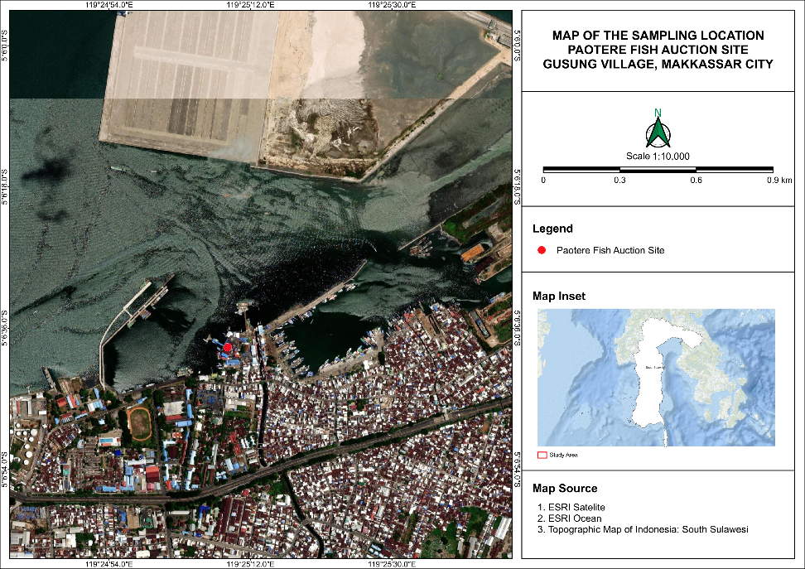
Figure 1. Sampling location
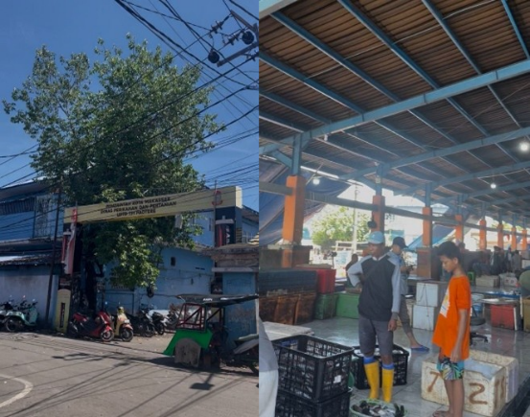
b)
a)
Figure 2. a) Paotere auction site, b) Collection point for fish from the waters off the coast of Spermonde, South Sulawesi
Laboratory Procedures
This research was conducted at the Marine Biology Laboratory, Faculty of Marine Sciences and Fisheries, Hasanuddin University, Makassar. Fish samples collected from the Paotere Fish Auction Site (TPI) were initially cleaned to eliminate debris from their body surfaces. The fins were spread using a 7% formalin solution to aid in the observation of morphological characteristics. Each specimen was labeled and documented before being preserved through immersion in a formalin solution for three days. Following this, they were rinsed under running water for three days to remove any residual formalin. Finally, the specimens were transferred to an alcohol solution for seven days as the concluding stage of preservation, preceding the observation of morphometric and meristic characteristics.
Morphometric and Meristic Analysis
Morphological characteristics of all Siganus fuscescens specimens were assessed through morphometric and meristic analyses. Morphometric measurements were conducted using a Vernier caliper with a precision of 0.01 mm, adhering to the methodology outlined by Randall and Kulbicki (2005). The parameters measured encompassed body dimensions, including total length, standard length, body depth, body width, as well as caudal-peduncle depth and length. Observations of head characteristics comprised head length, snout length, orbital diameter, interorbital width, cheek depth, and upper-jaw length. Additionally, fin characteristics were measured, including predorsal length, preanal length, prepelvic length, and the lengths of the spines and rays of the dorsal, anal, and pelvic fins, as well as pectoral fin length, caudal fin length, and the depth of the caudal fin notch (Figure 3).
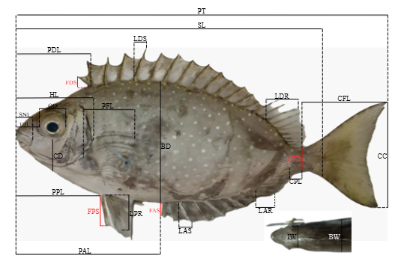
Figure 3. External morphology of Siganus fuscescens showing the observed morphometric characters: (TL) total length, (SL) standard length, (BD) body depth, (BW) body width, (HL) head length, (SNL) snout length, (OD) orbital diameter, (IW) interorbital width, (CD) cheek depth, (UJL) upper jaw length, (CPD) caudal peduncle depth, (CPL) caudal peduncle length, (PDL) predorsal length, (PAL) preanal length, (PVL) prepelvic length, (FDS) first dorsal spine, (LDS) longest dorsal spine, (LDR) longest dorsal ray, (FAS) first anal spine, (LAS) longest anal spine, (LAR) longest anal ray, (CFL) caudal fin length, (CC) caudal cavity, (PFL) pectoral fin length, (FPS) first pelvic spine, and (LPR) longest pelvic rays
RESULTS AND DISCUSSION
Morphological Description
Biogeographically, Siganus fuscescens is a herbivorous fish species found in tropical to subtropical regions, particularly within the Western Pacific (Wu et al., 2020). Empirical evidence supports the presence of this species in coastal areas, such as Mannar Bay, India, where specimens have been collected from shallow waters at depths of approximately 1–5 m (Eshwar et al., 2024). This suggests an association of the species with productive shallow coastal environments. Ecologically, these conditions indicate S. fuscescens' affinity for coastal habitats like coral reefs and seagrass beds, which are abundant in benthic algae, its primary food source. In Indonesia, the presence of S. fuscescens is corroborated by catch data from the coastal region of South Sulawesi, specifically from the Paotere Fishing Port (TPI) in Makassar, which receives fish from the Spermonde Islands region. According to Burhanuddin et al. (2014), members of the Siganidae family typically inhabit shallow waters less than 15 m deep and are found in various coastal habitats, including coral reefs, estuaries, and rocky substrates. Consequently, the specimens observed in this study are more accurately associated with the general habitat characteristics of Siganidae, rather than serving as a direct indicator of the specific distribution of S. fuscescens in that region.
The observed specimens exhibit the characteristic morphology of the Siganidae family, specifically an oval-shaped body that is somewhat rounded and laterally compressed, as noted by Zolkaply et al. (2021). Members of the Siganidae family display morphological variations that can be categorized into "slender-bodied" and "deep-bodied" types based on the standard length to body depth ratio, a key parameter in the taxonomic delimitation of the genus Siganus. This variation indicates morphometric differentiation among species, although the laterally compressed body shape remains the primary diagnostic characteristic of the Siganidae family. Key morphometric characters, particularly body depth and head structure, align with the general range for Siganidae. As shown in Table 1, the average body depth reaches 50% of the standard length (SL), and head length is 32.4% of SL, serving as important diagnostic parameters in distinguishing the slender-bodied and deep-bodied morphological groups, as reported by Zolkaply et al. (2021). The medium-sized head, with an orbital diameter of approximately 9.6% of SL, suggests relatively large and protruding eyes, an adaptation to shallow-water environments with high light intensity. The small, terminal mouth structure (upper jaw length ±7.3% SL) supports the herbivorous feeding strategy common in the genus Siganus, which relies on benthic algae and macroalgae as primary food sources (Wu et al., 2020). Additionally, the combination of hard spines and soft rays on the dorsal and anal fins is a significant diagnostic character that contributes to passive defense and swimming stability, while the forked caudal fin facilitates efficient movement in both open and complex aquatic habitats.
Meristic Characteristics
According to Table 2, the meristic characteristics of the three Siganus species exhibit uniformity in several key fin elements. Specifically, the Dorsal Fin Spine (DFS), Dorsal Fin Rays (DFR), Anal Fin Spine (AFS), and Anal Fin Rays (AFR) consistently display values of DFS = 13, DFR = 10, AFS = 7, and AFR = 9 across all species examined. This uniformity suggests that these characteristics are conserved within the genus Siganus, showing minimal variation among species. This pattern of stability in major meristic characters has also been documented by Anam et al. (2020) and Sahabuddin et al. (2015), indicating that these traits remain relatively constant across different aquatic environments.
Table 1. Morphometric measurements of Siganus fuscescens in the Spermonde Islands
 | Siganus fuscescens
Character | N=50
Morphometric | Mean ± SE (Range)
Total length | 160.1 ± 12.5 (112.8–182.4)
Standard Length | 133.2 ± 10.1 (94–154.6)
%SL
Body depth | 50±4.7 (35–58.3)
Body width | 15.2 ± 2.7 (9.8–29.7)
Head length | 32.4 ± 2.5 (24.5–37.7)
Snout length | 11.5 ± 1.8 (8.8–15.5)
Orbital diameter | 9.6 ± 1 (4.8–10.7)
Interorbital width | 10.8 ± 2.1 (6.2–16.8)
Cheek depth | 14.4 ± 1.7 (9.5–18.1)
Upper-jaw length | 7.3 ± 1.1 (4.5–9.6)
Caudal peduncle depth | 7.2 ± 0.8 (4.9–8.5)
Caudal peduncle length | 6 ± 1.1 (3.4–9.1)
Predorsal length | 30 ± 2.8 (24.7–36.2)
Preanal length | 64.3 ± 6.7 (28.7–73.3)
Prepelvic length | 35.1 ± 5.7 (29.3–67.8)
First dorsal spine | 9.2 ± 1.5 (3.6–11.5)
Longest dorsal spine | 15.5 ± 1.4 (10.5–17.9)
Longest dorsal ray | 13.3 ± 1.3 (9.2–16.2)
First anal spine | 9.9 ± 1.7 (6.9–19.7)
Longest anal spine | 14.5 ± 1.3 (9.7–17.8)
Longest anal ray | 11 ± 1.8 (7.3–18.9)
Caudal fin length | 34.1 ± 4.2 (21.1–40.4)
Caudal concavity | 2.4 ± 2.3 (0.3–8.3)
Pectoral fin length | 23.5 ± 4.2 (12.7–32.7)
First pelvic spine | 16.3 ± 1.4 (12–18.6)
Longest pelvic ray | 15.7 ± 1.6 (10–18.4)
Table 2. Comparison of meristic characters among Siganus species
Species | DFS | DFR | AFS | AFR | VFS | VFR | PFR | CFR | Source
Siganus fuscescens | 13 | 10 | 7 | 9 | 2 | 3 | 15–17 (16) | 19–21 (19) | This study
Siganus canaliculatus | XII–XIV | 10–11 | VII–VIII | 8–9 | 5–6 | 5–6 | 13–16 | 18 | Anam et al., (2020); Sahabuddin et al., (2015)
Siganus stellatus | XIII | 10 | VII | 9 | - | - | 17 (17–18) | 20 | Anam et al., (2020)
Data on Siganus fuscescens obtained in this study indicate Pectoral Fin Rays (PFR) values ranging from 15 to 17 and Caudal Fin Rays (CFR) values ranging from 19 to 21. In contrast, Anam et al. (2020) report that Siganus canaliculatus exhibits PFR values of 13 to 16 and a CFR value of approximately 18, while Siganus stellatus shows PFR values of 17 to 18 and a CFR value of approximately 20. These variations highlight differences among species within the same genus, particularly in pectoral and caudal fin characteristics, which may reflect adaptations to aquatic environments and differences in maneuverability. Overall, the characters DFS, DFR, AFS, and AFR are stable and thus more appropriate for use as genus-level identifiers. Conversely, the PFR and CFR traits exhibit more significant variation among species, including S. fuscescens, S. canaliculatus, and S. stellatus, rendering them potentially useful as distinguishing traits at the species level within the genus Siganus. This suggests that while morphological variation among species remains within the genus's conservative pattern, it is sufficiently informative to support taxonomic identification.
Coloration
The body color pattern predominantly exhibits a grayish-brown hue with a dorsoventral gradient, characterized by a darker dorsal region compared to the lighter ventral region. This pattern aligns with the counter-shading mechanism, a common camouflage strategy in shallow-water fish, which reduces detection by predators from various angles. Phenotypic variation, such as fine spots on the body, is frequently utilized in the taxonomic description of Siganus, alongside other morphometric characteristics including body depth, snout shape, and body coloration (Zolkaply et al., 2021). Nonetheless, color expression may display intraspecific variation, influenced by both ontogenetic and environmental factors.
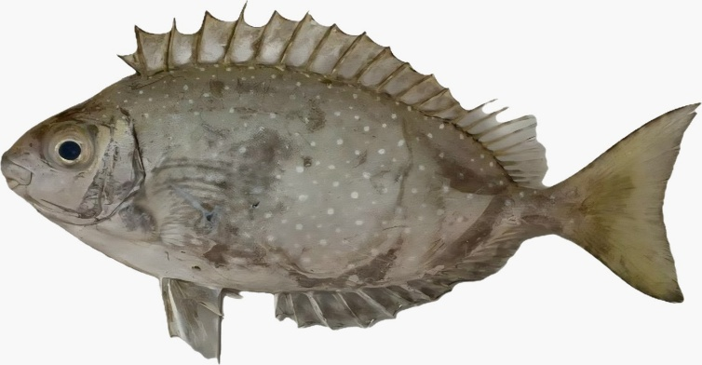
Figure 4. Lateral view of a Siganus fuscescens specimen from the Spermonde Islands, South Sulawesi, Indonesia
Principal Component Analysis (PCA)
Principal Component Analysis (PCA) was employed to discern the primary patterns of morphometric variation within the Siganus fuscescens population. The analysis results are depicted as a loading plot in Figure 5.
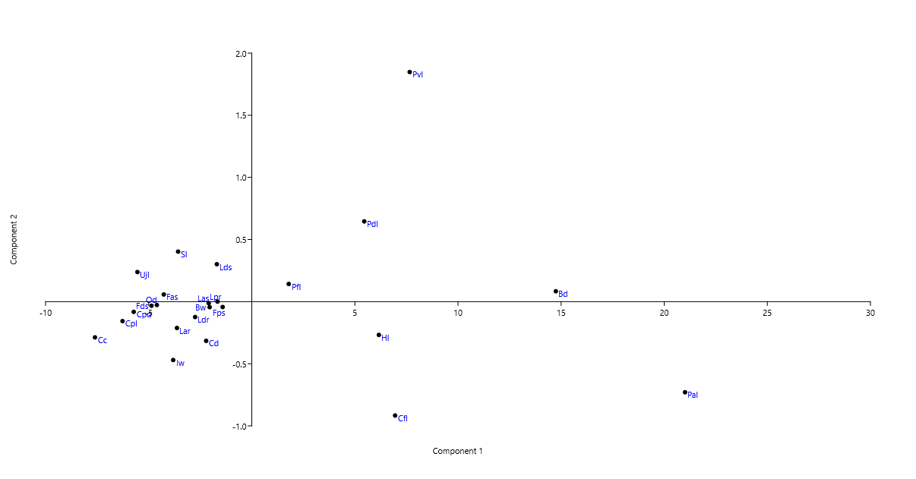
Figure 5. Loading plot of the Principal Component Analysis (PCA) for the morphometric characters of Siganus fuscescens
The principal component analysis (PCA) results for the morphometric characters of Siganus fuscescens (Figure 5) reveal an uneven distribution of variables on the loading plot, indicating varying contributions of each character to morphological variation. Variables such as Bd and Pal, which exhibit high loading values on the first principal component (PC1), suggest that PC1 primarily represents variations in body shape, particularly distinguishing between deeper-bodied and more elongated forms, a key axis in fish body shape variation (Claverie & Wainwright, 2014). In contrast, variables such as Cc, Cpl, and Cpds, which cluster on the negative side of PC1, indicate a close morphometric relationship among these characters. The proximity of these variables in PCA space reflects high correlations associated with allometric patterns, specifically the covariation among body parts influenced by the organism’s growth and size (Klingenberg, 2016). On the second principal component (PC2), variables such as Pvl and Pdl demonstrate relatively high contributions and are distinct from other variables, indicating that this component is more closely related to variations in fin structure. Variations in fins are crucial for a fish’s swimming ability and maneuverability, particularly through the role of the posterior body region in enhancing acceleration and responses to environmental pressures such as predation (Langerhans & Reznick, 2010). Therefore, the separation of variables into PC1 and PC2 suggests that the morphometric variation in Siganus fuscescens is influenced not only by differences in body shape but also by functional aspects related to environmental adaptation.
Table 3. Principal Component Analysis (PCA) of morphometric characters of Siganus fuscescens
Morphometric Characters | PC 1 (95.04%) | PC 2 (1.92%) | PC 3 (1.08%)
Pre-dorsal Length (Pdl) | 22.45 | -1.12 | 0.58
Pre-anal Length (Pal) | 8.12 | 0.76 | -0.24
Lower Jaw Length (Lar) | 7.9 | 1.05 | 0.31
Head Length (Hl) | 6.85 | 0.22 | -0.12
Standard Length (Sl) | -3.75 | -0.08 | 0.15
Eigenvalue | 42.18 | 0.85 | 0.48
Cumulative Variance (%) | 95.04 | 96.96 | 98.04
The Principal Component Analysis (PCA) of the morphometric characters of Siganus fuscescens reveals that PC1 accounts for 95.04% of the variation, with an eigenvalue of 42.18 (Table 3). This suggests that morphological variation is predominantly influenced by body size, with significant contributions from Pre-dorsal Length (Pdl), Pre-anal Length (Pal), Lower Jaw Length (Lar), and Head Length (Hl). The predominance of PC1 is typical in fish morphometric analyses, where the first component generally represents overall body size variation (Cadrin, 2000; Klingenberg, 2016). The high loading of Pdl indicates a notable contribution of the anterior body region, particularly the position of the dorsal fin, to morphological variation. The contributions of PC2 (1.92%) and PC3 (1.08%) (Table 3) are considerably smaller, indicating minimal shape variation within the population. For PC2, Lar and Pal exhibit relatively higher contributions, suggesting minor variations in head structure and the ventral body region. This variation is related to trophic aspects, as marine herbivorous fish, including members of the Siganidae family, are associated with the consumption of algae and benthic material in coral reef ecosystems (Clements et al., 2009). Overall, the low contributions of PC2 and PC3 indicate a high degree of morphological uniformity among individuals within the population.
CONCLUSION
Morphometric and meristic analyses reveal that Siganus fuscescens from the Spermonde Islands exhibits morphological traits consistent with the species' diagnostic features, with body size being the predominant factor in morphological variation. The primary meristic characters, specifically the number of spines and rays in the dorsal and anal fins, display relatively conservative patterns, thereby facilitating identification at the genus level. In contrast, variation in the number of rays in the pectoral and caudal fins may serve as interspecific distinguishing features within the genus Siganus. Principal Component Analysis (PCA) results indicate that over 95% of morphological variation is accounted for by the first principal component, which correlates with body size, while interindividual shape variation is minimal, indicating morphological uniformity within the population. Overall, the morphometric, meristic, and multivariate analysis approaches effectively support the taxonomic identification of S. fuscescens and enhance understanding of the species' morphological characteristics in the Spermonde Islands, providing baseline data for research on fish taxonomy and biodiversity.
ACKNOWLEDGMENT
The author expresses profound gratitude to Prof. Dr. Andi Iqbal Burhanuddin for his invaluable guidance, direction, and steadfast support throughout this research. Appreciation is also extended to Ardyansyah Kabar and Nurjirana for their constructive suggestions and assistance during the research process. The staff of the Marine Biology Laboratory, Faculty of Marine Science and Fisheries, Hasanuddin University, are acknowledged for providing laboratory facilities and technical support throughout the study. Lastly, the author thanks all individuals who contributed to the sampling process and the completion of this study.
REFERENCES
Anam, R. O., Mwatete, C. M., & Wambiji, N. (2020). Morphological and meristic characters of six rabbitfish species (Family: Siganidae) in Kenya. Western Indian Ocean Journal of Marine Science, 19(2), 89–103. https://doi.org/10.4314/wiojms.v19i2.7
Bennett, S., & Bellwood, D. R. (2011). Latitudinal variation in macroalgal consumption by fishes on the Great Barrier Reef. Marine Ecology Progress Series, 426, 241–252. https://doi.org/10.3354/meps09016
Brian Langerhans, R., & Reznick, D. N. (2010). Ecology and evolution of swimming performance in fishes: Predicting evolution with biomechanics. Fish Locomotion: An Eco-Ethological Perspective, 212–260. https://doi.org/10.1201/b10190
Burhanuddin, A. I., Budimawan, & Sahabuddin. (2014). The RabbitFshes (Family Siganidae) From The Coast Of Sulawesi, Indonesia. International Journal of Plant, Animal and Environmental Sciences, 4(4), 95–102.
Burhanuddin, A. P., Budiarsa, I. M., Kundera, I. N., Ramadhan, A., Jayanti, Z. D., & Trianto, M. (2025). Analisis Karakter Morfologi Untuk Menentukan Hubungan Kekerabatan Jenis Ikan Baronang (Siganus spp.) di Desa Labean Kabupaten Donggala. Bioscientist : Jurnal Ilmiah Biologi, 13(3), 1815–1824. https://doi.org/10.33394/bioscientist.v13i3.16463
Cadrin, S. X. (2000). Advances in morphometric identification of fishery stocks. Reviews in Fish Biology and Fisheries, 10(1), 91–112. https://doi.org/10.1023/A:1008939104413
Carpenter, R. C. (1986). Partitioning Herbivory and Its Effects on Coral Reef Algal Communities. Ecological Monographs, 56(4), 345–364. https://doi.org/10.2307/1942551
Claverie, T., & Wainwright, P. C. (2014). A morphospace for reef fishes: Elongation is the dominant axis of body shape evolution. PLoS ONE, 9(11), 1–11. https://doi.org/10.1371/journal.pone.0112732
Clements, K. D., Raubenheimer, D., & Choat, J. H. (2009). Nutritional ecology of marine herbivorous fishes: Ten years on. Functional Ecology, 23(1), 79–92. https://doi.org/10.1111/j.1365-2435.2008.01524.x
Eshwar Chandra Vidya Sagar, P., Bheemeswararao, K., Swapna, N. M., Prasad, G. S., & Dharmakar, P. (2024). First record of a mottled spine foot, Siganus fuscescens (Houttuyn, 1782), from the Gulf of Mannar, India. Environment Conservation Journal, 25(3), 640–645. https://doi.org/10.36953/ECJ.26702784
Hughes, T. P., Rodrigues, M. J., Bellwood, D. R., Ceccarelli, D., Hoegh-Guldberg, O., McCook, L., Moltschaniwskyj, N., Pratchett, M. S., Steneck, R. S., & Willis, B. (2007). Phase Shifts, Herbivory, and the Resilience of Coral Reefs to Climate Change. Current Biology, 17(4), 360–365. https://doi.org/10.1016/j.cub.2006.12.049
Klingenberg, C. P. (2016). Size, shape, and form: concepts of allometry in geometric morphometrics. Development Genes and Evolution, 226(3), 113–137. https://doi.org/10.1007/s00427-016-0539-2
Latuconsina, H., Lestaluhu, R., & Rumasoreng, R. (2020). Reproduction of White-Spotted Rabbitfish (Siganus canaliculatus Park, 1797) in the Waters of the Buntal Island, Kotania Bay, West Seram-Mollucas. Agrikan: Jurnal Agribisnis Perikanan, 13(2), 470–478. https://doi.org/10.29239/j.agrikan.13.2.470-478
Musyeri, P., Manangkalangi, E., Sembel, L., Toha, A. H. A., & Tebaiy, S. (2025). Komposisi ukuran dan pola pertumbuhan ikan baronang lingkis Siganus canaliculatus di Perairan Kwatisore , Kabupaten Nabire. Cassowary, 8(3), 86–94. https://doi.org/10.30862/casssowary.cs.v8.3.474
Nanual, B. J., & Metillo, E. B. (2008). Population Structure and Reproductive Biology of Siganus fuscescens Houttuyn 1782 (Perciformes, Siganidae) in Pujada Bay, Southeastern Mindanao, Philippines. The Philippine Scientist, 45, 62–79. https://doi.org/10.3860/psci.v45i0.992
Nielsen, S., Walburn, J. W., Vergés, A., Thomas, T., & Egan, S. (2017). Microbiome patterns across the gastrointestinal tract of the rabbitfish Siganus fuscescens. PeerJ, 2017(5), 1–16. https://doi.org/10.7717/peerj.3317
Sahabuddin, Iqbal Burhanuddin, Asmi Citra Malina, N. (2015). Morphometrics and Meristics of Rabbitfish (Siganus canaliculatus PARK, 1797) in the Bone Bay and Makassar Strait. Torani (Jurnal Ilmu Kelautan Dan Perikanan), 25(April), 44–52.
Shih, H. H., & Jeng, M. S. (2002). Hysterothylacium aduncum (Nematoda: Anisakidae) infecting a herbivorous fish, Siganus fuscescens, off the Taiwanese coast of the Northwest Pacific. Zoological Studies, 41(2), 208–215.
Tripathy, B., Swain, S. N., & Acharya, U. R. (2024). Morphological and molecular evidence for the first records and range extension of two marine fish species Pomadasys andamanensis and Siganus fuscescens to Odisha Coast , Bay of Bengal requires accurate data on the species distribution. Journal of Biodiversity and Environmental Sciences, 25(1), 143–154.
Wu, Y., Xiao, F., Wang, C., Shu, L., Zheng, X., Xu, K., Yu, X., Zhang, K., Luo, H., Yang, Y., He, Z., & Yan, Q. (2020). The Beta-Diversity of Siganus fuscescens-Associated Microbial Communities From Different Habitats Increases With Body Weight. Frontiers in Microbiology, 11(July), 1–13. https://doi.org/10.3389/fmicb.2020.01562
Zolkaply, S. Z., Do, T. D., Asaduzzaman, M., Seah, Y. G., Hurwood, D., Mather, P., Rahman, M. M., & Wong, L. L. (2021). Evolutionary history and taxonomic reappraisal of coral reef rabbitfishes (Siganidae): Patterns of lineage diversification and speciation. Biology, 10(11), 1–19. https://doi.org/10.3390/biology10111109

