ANALYSIS OF SEA LEVEL HEIGHT USING THE DELFT3D MODEL DURING THE SUPERMOON PHENOMENON IN THE COASTAL AREA OF LAMPUNG IN 2025​
Nur Fitri Rahmadani¹, Aries Kristianto¹

Submitted: August 7, 2026 Accepted: September 20, 2026
¹School of Meteorology, Climatology, and Geophysics, Tangerang, Banten
Corresponding Author:
*Nur Fitri Rahmadani
E-mail: nfr.fitri@gmail.com
ABSTRACT
Astronomical phenomena such as Supermoon cause tides to be generally higher than under normal conditions. This study aims to test the accuracy of the Delft3D hydrodynamic model in simulating sea level, analyze the impact of the 2025 Supermoon phenomenon on sea level variations along the coast of Lampung, as well as the influence of meteorological factors on sea level variations. The data used includes u and v wind components and air pressure data from ECMWF, National Bathymetry data, TPXO tidal components, and observed sea level data from tide gauge stations of Badan Informasi Geospasial. Model verification results show a high correlation coefficient, namely 0.95–0.98, with RMSE values ranging from 0.069–0.136 m, indicating a good agreement between simulation results and observational data. The research results indicate that the Delft3D model is able to simulate sea level with good accuracy, and sea level variation along the coast of Lampung is more influenced by astronomical factors than by meteorological factors.
Keywords: sea level, tides, Delft3D, supermoon.
INTRODUCTION
Indonesia is a country that is vulnerable to coastal disasters because it is among the nations with the longest coastlines in the world. One form of vulnerability threatening coastal areas is Sea Level Rise (SLR). Coastal flooding occurs when rising sea levels cause seawater to inundate coastal land with low elevation and gentle topography. Sea level rise has significant negative impacts on coastal settlements, affecting not only the environment but also causing social and economic losses. The most influential factor contributing to sea level rise is tides.
Tides are periodic changes in sea level caused by the gravitational pull between celestial bodies, especially the sun and the moon, on the mass of seawater on Earth. The astronomical phenomenon that causes higher high tides and lower low tides compared to regular full moon tides is called the Supermoon. The Supermoon occurs when the full moon reaches its closest distance to Earth, making the moon appear larger and brighter from the Earth's surface. In addition to astronomical factors, changes in sea level can also be influenced by meteorological factors such as wind conditions and air pressure, particularly during storms.
The phenomenon that causes sea level rise is generally modeled by conducting simulations in affected areas, one of which is Delft3D. Delft3D uses a multidisciplinary approach and methods for modeling coastal, river, and marine areas. , conducted a coastal flood simulation in Pontianak using the Delft3D model on 4 tidal flood events. The research results show that the correlation between the Delft3D model output and tidal observations was 0.93 and 0.96, respectively, and the analysis of meteorological factors found that, in general, tidal floods were dominated by the influence of sea waves, wind direction, and wind speed impacting the Pontianak coast. , also conducted a sea level height simulation using Delft3D modeling to predict the distribution of tidal floods along the Jakarta coast. The Delft3D model was able to predict sea level height with a correlation coefficient of 0.93 and an RMSE value of 0.13.
BMKG states that the Supermoon phenomenon occurring in 2025 has the potential to increase sea level in coastal areas. The coast of Lampung is an area vulnerable to sea level rise. The significant increase in sea level on the coast of West Lampung, at 5.46 mm/year, results in a high risk of tidal flooding. Tidal floods occurring on the coast of Bandar Lampung happen at least three times a year. In 2020, 7 events were recorded, 11 events in 2021, 6 events in 2022, 10 events in 2023, and 14 events in 2024.

MATERIALS AND METHODS
Time and Location of Research
This research was conducted on the coast of Lampung, as shown in Figure 1, during 3 periods of the Supermoon phenomenon occurring in 2025. The first Supermoon period took place on October 06–08, 2025, the second Supermoon period on November 04–06, 2025, and the third Supermoon period on December 03–05, 2025. The location focused on for sea level height observations is shown in Table 1:
Table 1. Station of Tidal
No. | Unit Code | Station Name | Latitude | Longitude
1 | KAGN | Kota Agung | 5.49072° | 104.61997°
2 | BKNT | Bengkunat | 5.63355° | 104.30680°
3 | KRUI | Krui | 5.18350° | 103.93310°
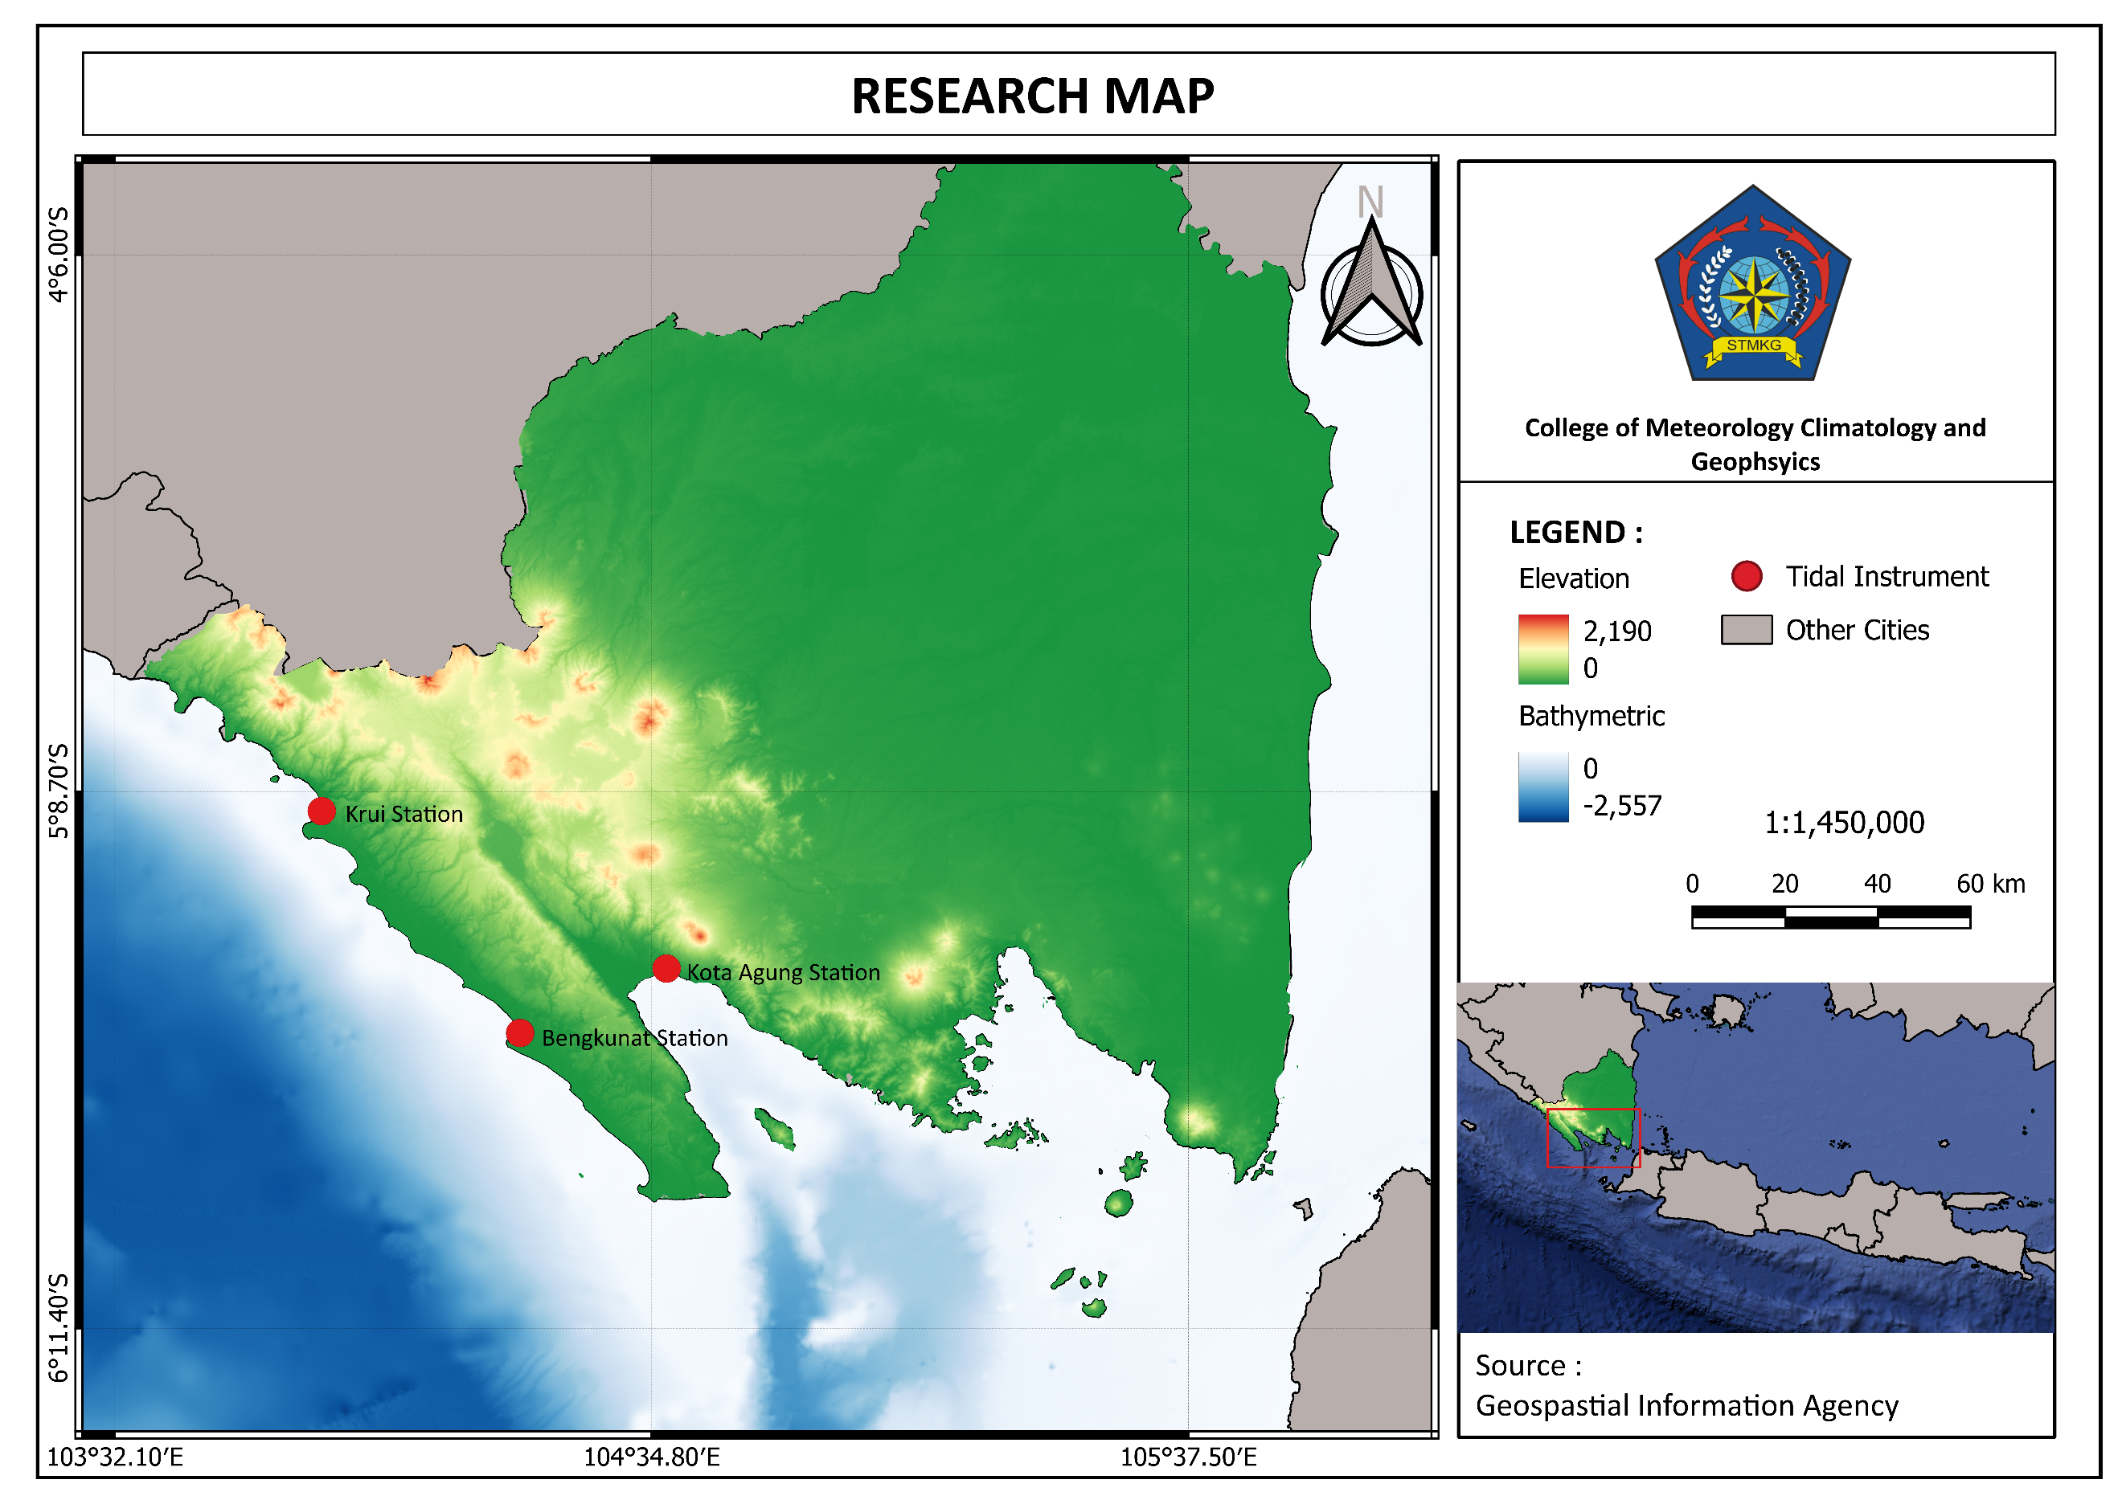
Figure 1. Map of the study location
Data Collection
The hydrodynamic model used is the DELFT3D Flow module with a simulation duration of 6 days prior to the observation period. After obtaining the DELFT3D modeling, analysis was then conducted. In this study, the input data used includes:
- Data Reanalysis European Centre for Medium-Range Weather Forecasts (ECMWF) ERA5-Hourly Data on Single Levels with a spatial resolution of 0.25° and a temporal resolution of 3 hours. The data used include the u and v wind components, as well as Mean Sea Level Pressure (MSLP). The data are used as atmospheric input data in Delft3D hydrodynamic modeling.
- National Bathymetry Data (BATNAS) sourced from the Geospatial Information Agency (BIG) is used to represent sea depth conditions in the modeling domain.
- Tidal constituent data. The data use the TPXO scheme developed by OSU Tide Models, with a spatial resolution of 1/12°.
- Sea Level Elevation Data from the Tidal Station of the Geospatial Information Agency (BIG) is used as validation data for the simulated sea surface height produced by the Delft3D model.

Data Analysis
The model verification process was carried out using two methods, namely Root Mean Square Error (RMSE) and the correlation coefficient. Meanwhile, the relationship between meteorological factors and sea level height was calculated using the correlation coefficient. The correlation coefficient is a number used to measure the strength of the relationship between variables. In correlation testing, the value ranges from -1 to 1 (Wilks, 2020), with the following equation:
$$r=n \frac{\sum{xy}-(\sum{x)(\sum{y})}}{\sqrt{\{n \sum{x^{2}- {(\sum{x)}}^{2}}\} \{n \sum{y^{2}- {(\sum{y)}}^{2}\}}}}$$
Description:
$r=$ Correlation coefficient
$x=$ variable 1
$y=$ variable 2
$n=$ number of data
RMSE is the result of the square root of the mean between the actual value and the predicted value. RMSE ranges from 0 to ∞ (infinity). The value of RMSE is defined by the following equation:
$$RMSE=\sqrt{\frac{1}{n}\sum_{i=1}^{n}{{\left(y_{i}- {\hat{y}}_{i}\right)}^{2}}}$$
Description:
$n$ = number of data
$y_{i}$ = model prediction data
${\hat{y}}_{i}$ = observation data
RESULTS AND DISCUSSION
Verification of the Delft3D model was carried out by comparing the simulation results with tidal data from the Geospatial Information Agency (BIG). The comparison results showed a correlation value between 0.95 and 0.98, indicating that the tidal patterns produced by the simulation closely match the observed patterns in the field. Meanwhile, the model error level measured using RMSE ranged from 0.069 m to 0.136 m. These values are relatively low, thus it can be concluded that the Delft3D model is capable of accurately simulating sea level during the studied period.
Table 2. Correlation results of three Supermoon cases
Case | Kota Agung |  | Bengkunat |  | Krui
Case | RMSE (cm) | r | RMSE (cm) | r | RMSE (cm) | r
Supermoon October | 12.31 | 0.956 | 12.11 | 0.949 | 13.60 | 0.944
Supermoon November | 13.07 | 0.964 | 13.48 | 0.946 | 12.06 | 0.950
Supermoon December | 12.14 | 0.969 | 9.09 | 0.975 | 6.92 | 0.985
Figure 2 shows the tides for each event at Kota Agung Station; the highest tide during the October Supermoon event (7 October 2025) occurred at 12:00 UTC with a height of approximately 0.65 meters, while the lowest tide occurred at 18:00 UTC with a height of approximately -0.20 meters. During the November Supermoon event (5 November 2025), the highest tide occurred at 11:30 UTC with a height of approximately 0.75 meters, and the lowest tide again occurred at 18:00 UTC at a height of -0.20 meters. As for the December Supermoon event (4 December 2025), the highest tide peaked at around 0.90 meters at 12:00 UTC, with the lowest tide remaining at -0.20 meters at 18:00 UTC.
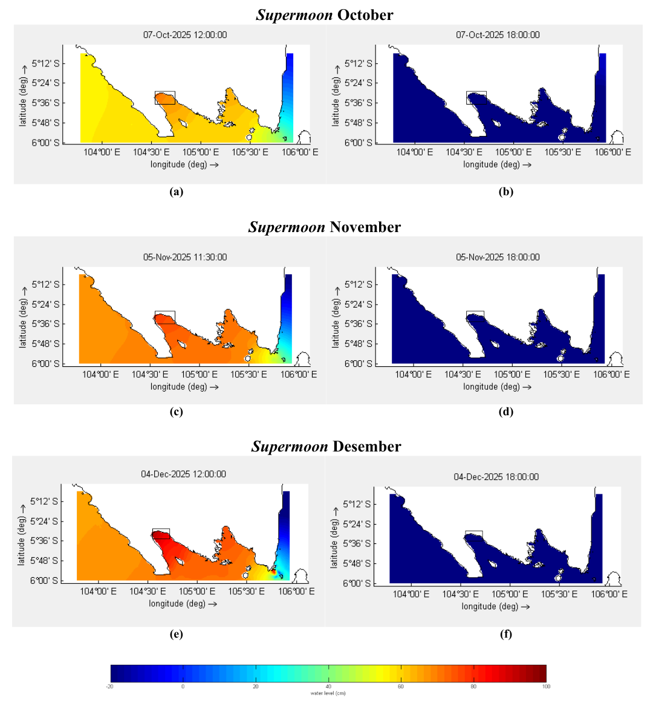
December
Figure 2. Sea level height (a) first case maximum (b) first case minimum (c) first second maximum (d) second case minimum (e) third case maximum (f) third case minimum, the black box is Kota Agung Station
A similar pattern was observed at the Bengkunat Station as shown in Figure 3. During the October Supermoon event, the highest tide reached approximately 0.60 meters at 12:00 UTC, with the lowest ebb at -0.20 meters at 18:00 UTC. During the November Supermoon event, the highest tide reached about 0.70 meters at 11:30 UTC, and the lowest ebb remained at -0.20 meters at 18:00 UTC. Meanwhile, during the December Supermoon event, the highest tide was recorded at around 0.65 meters at 12:00 UTC, with the lowest ebb at -0.20 meters at 18:00 UTC.

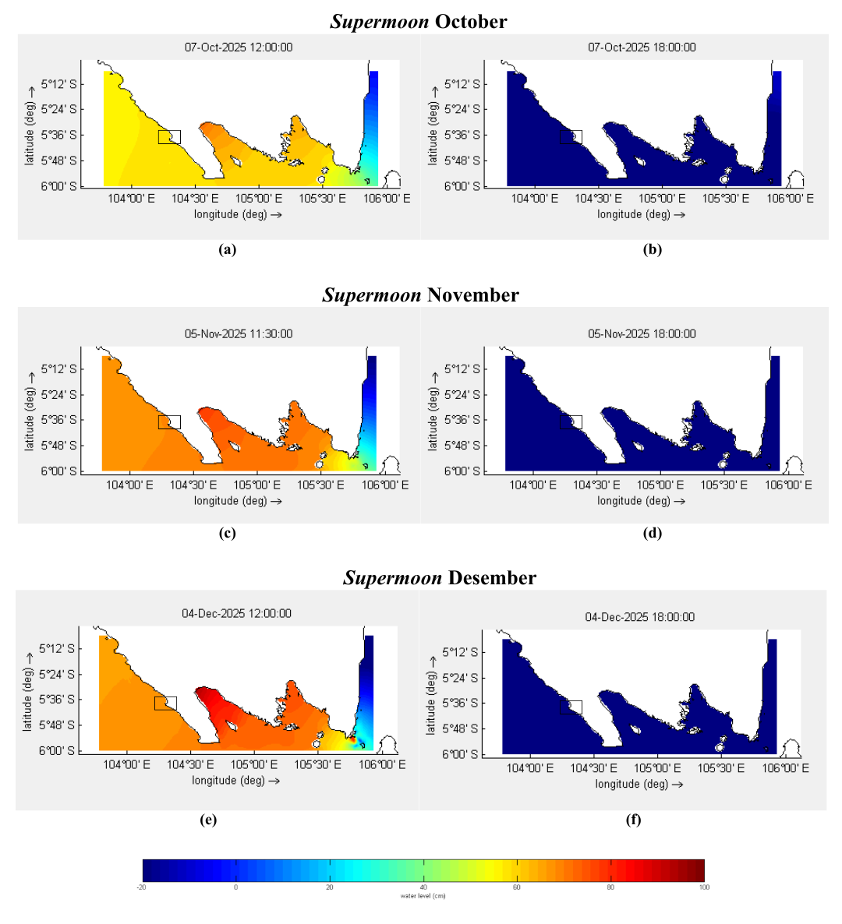
December
Figure 3. Sea level height (a) first case maximum (b) first case minimum (c) first second maximum (d) second case minimum (e) third case maximum (f) third case minimum, the black box is Bengkunat Station
Sea level at Krui Station as shown in Figure 4, the highest tide during the October Supermoon event reached approximately 0.55 meters at 12:00 UTC, with the lowest ebb at -0.20 meters at 18:00 UTC. During the November Supermoon event, the highest tide reached around 0.65 meters at 11:30 UTC, with the lowest ebb at -0.20 meters at 18:00 UTC. Meanwhile, during the December Supermoon event, the highest tide was recorded at about 0.60 meters at 12:00 UTC, with the lowest ebb at -0.20 meters at 18:00 UTC.
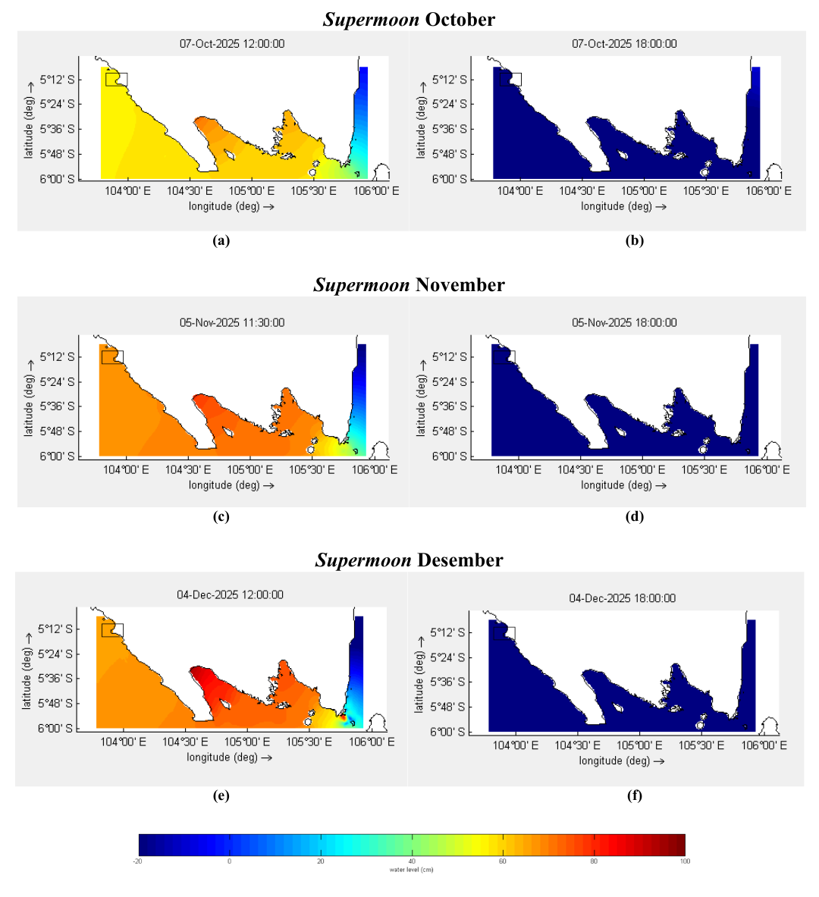
December
Figure 4. Sea level height (a) first case maximum (b) first case minimum (c) first second maximum (d) second case minimum (e) third case maximum (f) third case minimum, the black box is Krui Station
The three Supermoon events showed a fairly high sea level. This condition is influenced by astronomical factors, namely the position of the moon approaching perigee, which is the point in the moon's orbit closest to the earth, thereby increasing the moon's gravitational pull on the mass of seawater. Higher tides tend to occur at Kota Agung Station; this is related to the shape of its waters, which resemble a bay and are relatively enclosed, so that the mass of water entering during high tide accumulates more easily compared to Bengkunat and Krui Stations, which have open waters.
Table 3. Correlation between meteorological factors and sea level
Station | Case | Wind |  |  | Air Pressure
Station | Case | Speed | U Component | V Component | Air Pressure
Kota Agung | Supermoon October | 0.23 | 0.26 | 0.45 | 0.04
Kota Agung | Supermoon November | 0.42 | 0.48 | 0.01 | 0.08
Kota Agung | Supermoon December | 0.27 | 0.39 | 0.14 | 0.10
Bengkunat | Supermoon October | 0.29 | 0.24 | 0.38 | 0.08
Bengkunat | Supermoon November | 0.29 | 0.55 | 0.15 | 0.03
Bengkunat | Supermoon December | 0.37 | 0.64 | 0.43 | 0.24
Krui | Supermoon October | 0.30 | 0.24 | 0.30 | 0.13
Krui | Supermoon November | 0.32 | 0.42 | 0.06 | 0.08
Krui | Supermoon December | 0.38 | 0.75 | 0.47 | 0.26
The correlation values between wind speed and sea level height vary but are generally low across all stations and events. The u and v wind components also show low correlation throughout all periods at each station. Similarly, the correlation between air pressure and sea level height consistently indicates a weak relationship across all stations and study periods. The low correlation values suggest that wind and air pressure do not have a strong association with sea level height variations in the study area.
CONCLUSION
The Delft3D hydrodynamic model is capable of accurately simulating sea surface height in the coastal region of Lampung, as indicated by strong correlation values across all six study periods and relatively small error values in each period. In addition, the astronomical factor—namely, the position of the moon—has a much more dominant influence on the increase in sea surface height compared to meteorological factors.
ACKNOWLEDGMENT
The author expresses gratitude to God Almighty for His blessings and grace, which enabled the author to complete the writing of this journal. The author also wishes to thank the Sekolah Tinggi Meteorologi, Klimatologi, dan Geofisika and all parties who have assisted in this research.
REFERENCES
Ariwibowo, F. S., Fadlan, A., dan Triatmoko, D. (2021). Kajian Perubahan Tinggi Muka Laut Pada Saat Siklon Tropis Dahlia Di Pesisir Lampung, Jurnal Widya Climago, Vol. 2, no. 2, pp 41
Azuga, N. A. (2021). Kerentanan Kawasan Pesisir Terhadap Bencana Kenaikan Muka Air Laut (Sea Level Rise) di Indonesia, Jurnal Riset Kelautan Tropis (Journal Of Tropical Marine Research) (J-Tropimar), Vol. 3, no. 2
Banno, M. and Kuriyama, Y. (2020). Supermoon Drives Beach Morphological Changes in the Swash Zone, Geophysical Research Letters, Vol. 47, no. 22
Damayanto, Moch. Z., Tubalawony, S., dan Noya, Y. A. (2024). Kajian Banjir Pesisir Menggunakan Model Delft3D Studi Kasus Wilayah Seram Bagian Timur, TRITON: Jurnal Manajemen Sumberdaya Perairan, Vol. 20. no. 1, pp 28–35
Deltares. (2025). Delft3D-Functional Specifications, Delft, Netherlands
Harito, R. R., Fatoni, I. K., dan Pranowo, S. W. (2020). Studi Perhitungan Muka Surutan Peta Berdasarkan Waktu Terjadi Supermoon Di Perairan Kalabahi Nusa Tenggara Timur, Jurnal Chart Datum, Vol. 6, pp 10–23
Hidayah, Z., Romadhon, A., dan Witjarnoko, Y. (2018). Penilaian Kerentanan Wilayah Pesisir Selatan Pulau Bawean terhadap Kenaikan Muka Air Laut, Jurnal Perikanan Universitas Gadjah Mada, Vol. 20. no. 2, pp 87–94
Iman, Arinda, R., Ardiansyah, dan Pratama, W. N. (2024). Penentuan Nilai Ambang Batas Dalam Prakiraan Potensi Banjir Pesisir di Utara Jakarta, Buletin Meteorologi, Klimatologi dan Geofisika, Vol. 5, no. 4, pp 35–43
Kristianto, A. dan Efendi, U. (2021). Prediksi Spasio Temporal Rob Berbasis Model LISFLOOD FP di Pesisir Jakarta, Majalah Geografi Indonesia, Vol. 35, pp 150–155
Kuntinah, Nugraheni, I. R., dan Ardianto, R. (2021). The Simulation of Water Level Using Delft3D Hydrodynamic Model to Analyze the Case of Coastal Inundation in Pontianak, Innovative Technology and Management Journal, Vol. 4
Kurniawan, A. P., Ihsan Jasin, M., dan Mamoto, J. D. (2019). Analisis Data Pasang Surut Di Pantai Sindulang Kota Manado, Jurnal Sipil Statik, Vol. 7, no. 5, pp 567–574
Kusumadewi, H. (2025). Coastal Vulnerability-Maritime Security Nexus: Insights from the Coast of Java Island, Coastal and Ocean Journal, Vol. 9, no. 1, pp 1–19
Mar’ah, M., Arifin, W. A., & Rosalia, A. A. (2025). Perbandingan random forest dan support vector machine dalam memprediksi banjir rob di Teluk Lampung. Jurnal Algoritma, 22(1), 1116-1126.
Nadzir, Z. A., Agung, H. N., dan Fahrurozi, F. (2025). Studi Kenaikan Muka Air Laut di Pesisir Lampung dan Banten menggunakan Satelit Altimetri, Vol. 7, no. 2, pp 106–121
NASA. (2025). Supermoons, https://science.nasa.gov/moon/supermoons/ , diakses tanggal 12 Desember 2025.
Supangat, A. dan Susana. (2003). Pengantar Oseanografi, Pusat Riset Wilayah Laut dan Sumberdaya Non-Hayati, BRPKP-DKP
Tiatama, S. H., Atmodjo, W., and Widiaratih, R. (2024). Analisis Keterkaitan Fenomena Supermoon Terhadap Komponen Pasang Surut Di Perairan Semarang, Jawa Tengah, Indonesian Journal of Oceanography, Vol. 6, no. 2, pp 114–120
Wilks, D. S. (2020). Statistical Methods in the Atmospheric Sciences, Elsevier

