Contrast of Atmospheric Trigger Mechanisms in Extreme Marine Heatwave Events in the Southern Java Upwelling System
Muhammad Fadhillah¹, Rafli Iqbal Taufiqi¹, Adilaksa Kharisma¹, Farhan Oktaviansyah Hidayat¹ , Yosafat Donni Haryanto¹

Submitted: August 11, 2026 Accepted: October 24, 2026
¹Meteorology Study Program, School of Meteorology, Climatology and Geophysics, Kota Tangerang, Banten 15221.
Corresponding Author:​​
*Yosafat Donni Haryanto
E-mail: yosafat.haryanto@stmkg.ac.id
ABSTRACT
Marine Heatwaves (MHWs) pose a substantial threat to marine ecosystems, with the physical mechanisms initiating these events in specific coastal regions potentially varying over time due to the prevailing phase of climate anomalies. This study seeks to compare the influence of surface wind stress and net solar radiation flux in initiating extreme MHW events within the Southern Java Upwelling System during 2016 and 2019. Sea surface temperature data were sourced from NOAA OISST version 2.1 satellite imagery, while wind and solar radiation components were derived from ECMWF ERA5 reanalysis data. MHW detection was based on the 90th percentile threshold of daily climatology, persisting for a minimum of five consecutive days. The findings indicate that the 2016 event was characterized by persistence, with absolute temperature peaks surpassing 30°C from March to April. This was triggered by a weakening of the southeast monsoon winds to an average of 2.3 m/s, which interrupted Ekman transport and diminished the influx of cold water from the thermocline layer. In contrast, the pronounced temperature increase in December 2019 was instigated by elevated net solar radiation, reaching 275 W/m² due to clear-sky conditions, while winds remained relatively calm following an earlier strengthening of upwelling. These findings underscore the necessity of comprehensive monitoring of atmospheric variables, beyond merely sea temperature, to enhance the reliability of marine early warning systems in Indonesia.
Keywords: Marine Heatwave; solar radiation; South of Java; upwelling; wind stress.
INTRODUCTION
Marine Heatwave (MHW) refers to episodes of extreme, persistent sea surface temperature anomalies that last for a specific duration and are now recognized as one of the main threats to the resilience of marine ecosystems across various parts of the world. The frequency and intensity of MHW have increased globally in recent decades (Oliver et al., 2018), while their impacts include mass coral bleaching, declines in primary productivity, and shifts in the spatial distribution of economically important marine biota (Smith et al., 2023). At the regional scale, an area’s vulnerability to MHW is strongly determined by the characteristics of local oceanographic dynamics and atmospheric circulation patterns, so that the forcing mechanisms can differ significantly between regions as well as between event periods within the same region (He et al., 2026; Pak et al., 2022). As an archipelagic country, most of whose waters are located in the tropical zone, Indonesia requires an understanding of the triggering mechanisms of MHW that is directly relevant to the sustainability of the capture fisheries sector and the management of marine conservation areas. This is important given that sudden temperature changes can disrupt the migration patterns of pelagic fish and accelerate coral reef degradation in coastal areas (Smith et al., 2023).
The southern Java waters constitute one of the tropical upwelling systems whose activity is governed by the Southeast Monsoon (Southern Java Upwelling System, SJUS) (Rachman et al., 2024; Susanto et al., 2001). In mid-year, easterly winds blowing relatively consistently from the Australian continent induce offshore Ekman transport, driving surface water masses away from the coastline and triggering the ascent of cold, nutrient-rich water masses from the thermocline layer to the surface (Safinatunnajah et al., 2021). This process routinely suppresses sea surface temperatures along the southern coast of Java and sustains pelagic fisheries productivity in the region (Wirasatriya et al., 2020). The consistency of the monsoon wind stress renders this system vulnerable to large-scale climate anomalies such as the El Niño Southern Oscillation (ENSO) and Indian Ocean Dipole (IOD), both of which are known to modulate both surface wind strength and the radiation balance in the eastern Indian Ocean (Rachman et al., 2024).
Most published studies on MHW have focused on characterizing the intensity, duration, and spatial extent of events, with atmospheric forcing generally treated as a single, uniform factor across occurrences. This approach tends to overlook the possibility that the same upwelling region can experience extreme MHW through entirely different physical pathways, depending on the prevailing phase of climate anomalies. Consistent with these physical mechanisms, weakening of monsoon wind stress can suppress Ekman transport and halt the supply of cold water from the thermocline (upwelling suppression) (Jayaram and Jose, 2022). In other conditions, strong post-upwelling wind stretching may leave behind a shallow and stagnant mixed layer, making it vulnerable to direct warming due to surges in shortwave radiation flux during clear-sky conditions (Pak et al., 2022). These two pathways, wind-driven upwelling suppression and radiation-driven clear-sky heating, have distinct physical signatures even though they both result in the same outcome—extreme sea surface temperature anomalies. Studies that directly compare these two forcing pathways in the same upwelling system, especially during extreme climate anomaly events such as the 2016 La Niña and the 2019 positive IOD, remain rare in previous research (Bayhaqi and Iskandar, 2026; Sen Gupta et al., 2020). This gap is important to address because mitigation strategies designed on the assumption of a single forcing may be incorrectly applied to MHW events that actually originate from nonlinear physical aspects, potentially reducing the effectiveness of early warning systems or adaptation recommendations for local fisheries stakeholders.
The years 2016 and 2019 were chosen as the study period because they represent two contrasting climate conditions in the eastern Indian Ocean. The year 2016 occurred during the decaying phase of a strong La Niña, when regional atmospheric circulation experienced a weakening that could anomalously suppress the easterly monsoon wind stress (L'Heureux et al., 2017). In contrast, 2019 was marked by the development of a strong positive IOD, which is generally associated with intensified upwelling in the middle of the year, but can potentially be followed by wind relaxation and a surplus of solar radiation during its decaying phase at the end of the year (Safinatunnajah et al., 2021). The contrasting macro-climate conditions between these two years provide a natural framework to test the hypothesis that the triggering mechanisms of MHW in the SJUS are conditional on the prevailing phase of climate anomalies, rather than being singular and uniform.
Based on the above description, this study aims to comprehensively compare the roles of surface wind stress and net surface solar radiation in triggering extreme MHW events in the SJUS in 2016 and 2019. Specifically, this study examines the spatiotemporal patterns of MHW in those two years using high-resolution satellite sea surface temperature data, and relates these patterns to reanalysis data of surface wind components and net solar radiation to identify the dominant physical pathways in each event. The results of this study are expected to provide an empirical basis for the development of a marine early warning system that considers more than one atmospheric variable, given that single temperature-based forcing alone has proven inadequate for capturing the diversity of MHW triggering mechanisms in tropical upwelling regions.
MATERIALS AND METHODS
Time and Location of the Study
This research is a secondary data analysis based on satellite remote sensing and atmosphere-ocean reanalysis data, without direct field data collection. The historical data analyzed covers the period from 1991 to 2020 for the purposes of climatology calculations and the detection of marine heatwave (MHW) events, with an in-depth focus on the full years of 2016 and 2019, as well as a composite spatial analysis centered on two peak periods of extreme events, namely March–April 2016 and December 2019. The study area is located in the southern waters of Java, directly bordering the Indian Ocean, encompassing a spatial domain of approximately 7°S–11°S and 105°E–114°E, as shown in Figure 1.

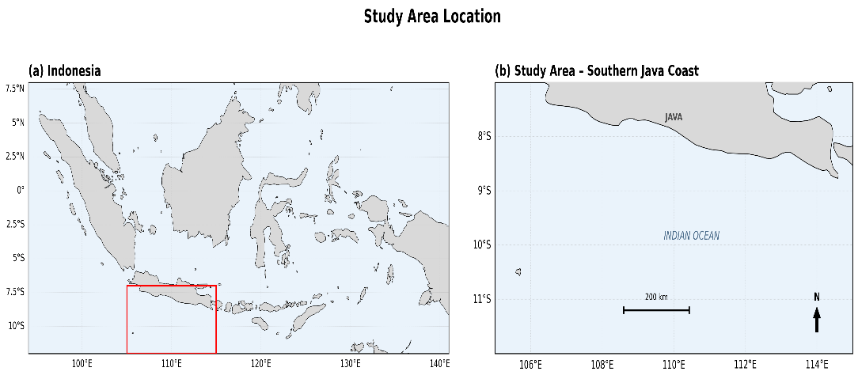
Figure 1. Map of the study area. (a) Map of Indonesia with the red box indicating the spatial domain of the study in the waters south of Java. (b) The study domain bordering the Indian Ocean, covering the southern coast of Java at approximately 7°S–11°S and 105°E–114°E.
Sea Surface Temperature Data
Sea surface temperature (SST) data were obtained from the NOAA Optimum Interpolation Sea Surface Temperature version 2.1 (OISST v2.1) satellite product with a daily spatial resolution of 0.25° x 0.25° (Huang et al., 2021). These data were used to construct a daily climatology as a baseline and to detect extreme temperature anomalies indicating MHW events in the study area.
Atmospheric Forcing Data
Atmospheric forcing data were obtained from the ECMWF ERA5 reanalysis product, which provides 10-meter surface wind components (zonal/u and meridional/v components) as well as surface net solar radiation (ssr) with daily temporal resolution (Hersbach et al., 2020). These two variables were respectively used to represent the intensity of monsoon wind stress and the state of cloud cover or surface insolation during the analyzed MHW events.
Detection and Categorization of Marine Heatwaves
Detection and categorization of MHW events refer to the standard hierarchical framework developed by Hobday et al. (2016), namely conditions in which daily SST exceeds the 90th percentile value of the baseline climatology for at least five consecutive days. Baseline climatology is calculated using a 30-year period following the general recommendations of standard climatology (1991–2020), with MHW intensity expressed as the difference between daily SST and the seasonal climatology value on the corresponding date. MHW severity categories (moderate, strong, severe, and extreme) are determined based on multiples of the difference between the 90th percentile value and the climatology, as defined in the categorization scheme of Hobday et al. (2018).
Dominant Forcing Mechanism Analysis
To identify the dominant forcing mechanisms in each event, a spatial and temporal composite analysis was conducted between SST anomalies and surface wind speed anomalies as well as net solar radiation anomalies during the peak periods of the 2016 and 2019 MHW events. This approach enables the identification of the relative contributions between weakened Ekman transport (wind-driven) and increased shortwave radiation flux (radiation-driven) to the development of extreme thermal anomalies in each period. All spatial data processing, anomaly calculations, and map visualizations were performed using a script-based programming language supporting multidimensional raster data analysis, allowing for consistent replication of the MHW detection process and atmospheric variable extraction for both study periods. The temporal characteristics of marine heatwave (MHW) events in the southern waters of Java during 2016 and 2019 were analyzed using daily SST time series compared against climatology and the 90th percentile threshold, as presented in Figure 2.
RESULTS AND DISCUSSION
Spatiotemporal Evolution of MHW 2016 and 2019
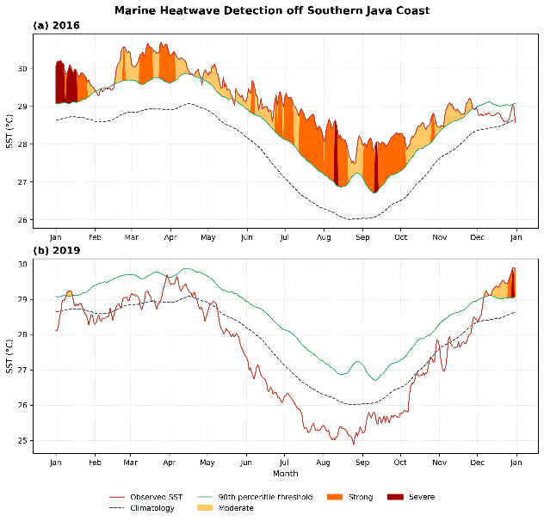
Figure 2. Detection of marine heatwave (MHW) events in the waters south of Java in (a) 2016 and (b) 2019, shown by daily observed SST (red line), climatology (dashed gray line), the 90th percentile threshold (green line), and MHW severity categories: Moderate (light yellow), Strong (orange), and Severe (dark red), following the classification scheme of Hobday et al. (2018).
In 2016 (Figure 2a), MHW conditions were recorded for nearly the entire year with varying intensities and categories. In early January, observed SST reached around 30.2°C and immediately fell into the Severe category for approximately the first two weeks, far exceeding the 90th percentile threshold, which ranged from 29.1–29.2°C. After a brief hiatus approaching climatology at the end of January to early February (~29.3°C), SST rose sharply again entering the March–April period, with the year's highest absolute temperature peak at around 30.5–30.6°C, classified as Strong to Moderate. The March–April period was selected to represent the peak of acute thermal stress because it recorded the highest absolute temperatures throughout the entire year.
As a comparison, the normal seasonal SST pattern in the southern Java waters without the presence of an MHW anomaly generally follows a unimodal cycle, with peak temperatures at the start of the year (west monsoon) and the lowest temperature trough in mid-year (upwelling season peak, July–September), as reflected in the climatological line (Figure 2). This climatological line shows an annual range of approximately 26.0–29.1°C, reflecting the normal seasonal amplitude caused by the annual upwelling-downwelling cycle (Wirasatriya et al., 2020). The observed SST in 2016 consistently remained above the 90th percentile threshold, even in months that, seasonally, should have been the coldest. This indicates that the anomaly in that year was not merely a shift in the seasonal phase, but represented a systemic deviation from the normal annual cycle.
An interesting pattern was observed during the August–October 2016 period. Although absolute SST during this period was much lower, dropping to around 26.7–26.9°C, the MHW status remained in the Strong to Severe category. This occurred because the seasonal climatology itself declined more sharply, reaching a low point of around 26.0°C in August–September due to the peak phase of the east monsoon, which should have cooled the waters through upwelling. In other words, SST failed to decrease as much as normal climatology would predict, so the positive anomaly relative to the seasonal baseline remained large despite low absolute temperatures. This condition indicates a disruption of the natural cooling mechanisms in the waters in mid-2016.
From the perspective of cumulative duration, the 2016 MHW event was far more persistent than in 2019. Throughout 2016, observed SST was almost always above the 90th percentile threshold except for brief intervals at the end of January and mid-May, meaning that most days of the year were classified as MHW conditions with varying levels of severity. In contrast, in 2019, MHW conditions were only observed over a much shorter duration, concentrated on several days in early January and late December, while the majority of that year was instead dominated by SST conditions below climatology due to intensified mid-year upwelling. This contrast in duration further supports the indication that these two years experienced fundamentally different ocean-atmosphere physical conditions, rather than merely variations in the intensity of the same forcing mechanism.
The 2019 pattern (Figure 2b) differed from 2016. From January–April 2019, SST generally followed the climatology (28.1–29.7°C) without any significant MHW excursion, except for a brief Moderate session in early January. Entering May through September, SST experienced a sharp and sustained decline far below both the climatology and the MHW threshold, reaching an annual minimum of approximately 24.9–25.0°C at the end of August. This value is even lower than the climatological minimum (~26.0°C) or the 2016 SST minimum (~26.7–26.9°C), indicating a stronger cooling than normal conditions in mid-2019, consistent with intensified upwelling due to a strong positive IOD that year (Safinatunnajah et al., 2021).
The most striking contrast in 2019 appeared in December. Within a period of less than one month, SST soared sharply from around 28.4°C near early December to nearly 29.9°C by the end of the year, reaching the Strong category and briefly touching the Severe category in just the last few days of the year. This extremely rapid warming rate suggests that its triggering mechanism is most likely fundamentally different from the mechanism operating during the more gradual March–April 2016 period. It is this difference in the rate of evolution that forms the basis of the hypothesis that these two extreme MHW events were driven by different atmospheric physical pathways.
SST and Surface Wind Conditions at the Peak of MHW
In identifying the role of surface wind stress in the formation of MHW in both years, a spatial analysis of sea surface temperature (SST) and surface wind vectors was conducted during the peak event periods, namely March–April 2016 and December 2019, as presented in Figure 3.
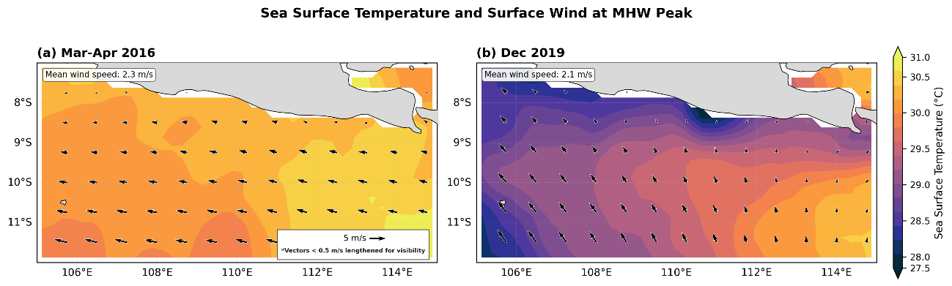
Figure 3. Spatial distribution of sea surface temperature (SST) and surface wind vectors at the peak of MHW events in (a) March-April 2016 and (b) December 2019 in the waters south of Java. Arrows indicate wind direction and speed (reference scale 5 m/s); vectors with speeds <0.5 m/s are elongated for visualization purposes.
During the peak of the MHW in March–April 2016 (Figure 3a), the surface wind field was recorded as very weak (2.3 m/s) with incoherent vector anomalies, directed northwest in coastal waters and southwest offshore. This condition represents the absence of consistent wind forcing to trigger offshore Ekman transport. Climatologically, the southeast monsoon south of Java should induce upwelling through wind stress that lifts cold water masses from the thermocline (Susanto et al., 2001; Wirasatriya et al., 2020). The weakening of this wind stress directly triggered upwelling suppression, as manifested in the homogenous and warm SST field (28.5–31°C) across the entire domain. The loss of a sharp temperature gradient between the coast and offshore, as a key indicator of active upwelling, confirms the cessation of cold water mass pumping from below. Dynamically, this reduction in Ekman circulation traps warm water mass in the coastal mixed layer, resulting in heat accumulation without an adequate convective cooling mechanism.
Although La Niña has historically been associated with the suppression of upwelling through thermocline deepening as a result of the strengthening of the Indonesian Throughflow (ITF) (Susanto et al., 2001), Figure 3a demonstrates that anomalies in the weakening of local alongshore winds were the dominant driver in March–April 2016, surpassing the effect of regional thermocline modulation. This disparity confirms that the interaction between local wind forcing and basin-scale climate modulation can operate independently in triggering thermal anomalies in the southern Java coastal system. The persistently systemic wind stress deficit in the first half of 2016 also explains why MHW with Severe status persisted until August–September, despite the decline in absolute temperature.
On the other hand, the MHW peak in December 2019 (Figure 3b) represents a different thermal dynamic. Although the average wind speed (2.1 m/s) was lower than during the March–April 2016 period, the 2019 SST spatial pattern still maintained a sharp coastal–offshore gradient. The relatively colder coastal waters (27.5–28.0°C) were residual traces of intense upwelling that occurred mid-year, while the extremely warm offshore areas (>30.5°C) indicate restratification and rapid surface heating following the monsoon stretching phase after upwelling.
Net Solar Radiation at MHW Peak
To explain the factors distinguishing the two MHW events, a spatial analysis of surface net solar radiation flux was conducted during the same peak period of the MHWs, as shown in Figure 4.
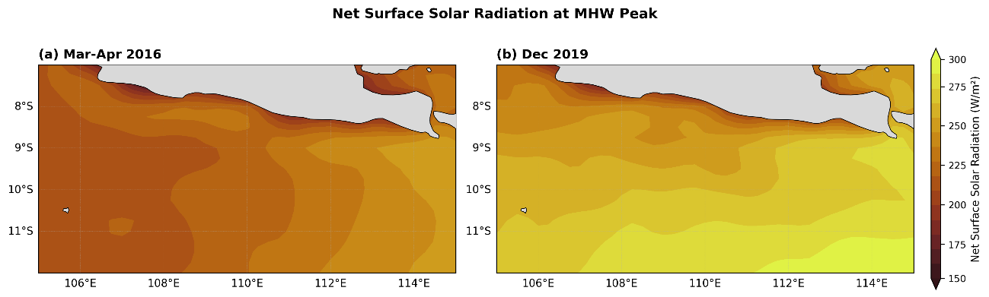
Figure 4. Spatial distribution of net surface solar radiation at the peak of MHW events in (a) March-April 2016 and (b) December 2019 in the waters south of Java.
During the March–April 2016 period (Figure 4a), surface net solar radiation generally ranged from 150–225 W/m², with the lowest values near the coast (150–175 W/m²) and moderate increases offshore (200–225 W/m²). These values are considered moderate and do not indicate exceptionally clear-sky conditions, suggesting that radiation was likely not the primary distinguishing factor in the MHW event that year. In sharp contrast, December 2019 (Figure 4b) showed a significant increase in net solar radiation, reaching over 275–300 W/m² across most of the southern offshore area within the study domain. Such high radiation values indicate very clear skies and minimal cloud cover (clear-sky condition), consistent with the typical atmospheric patterns accompanying the decay phase of a positive IOD in the region.
The month of December climatologically coincides with the approach of the summer solstice in the Southern Hemisphere, resulting in a natural tendency for the average daily solar radiation to increase during this period compared to the mid-year months (Wallace & Hobbs, 2006). The net radiation values in Figure 4b, which exceed 275 W/m² across most of the study domain, remain high even relative to the normal seasonal pattern. This indicates the presence of an additional anomalous component in the form of reduced cloud cover beyond typical seasonal variation. It is this positive net radiation anomaly—not simply the seasonal cycle—that serves as the primary driver for the formation of an SST spike that far exceeds the normal seasonal warming rate within a span of less than one month.
Theoretically, sea surface temperature anomalies on weekly to seasonal scales are a function of the mixed layer heat budget, which is determined by the balance between net surface heat flux—namely, shortwave radiation, longwave radiation, latent heat, sensible heat—and vertical mixing processes that distribute this heat throughout the entire depth of the mixed layer (Sen Gupta et al., 2020). Based on this heat budget framework, when the mixed layer depth is reduced due to weakened wind-driven mixing, the same magnitude of net surface heat flux will produce a much higher SST warming rate, as the incoming energy is concentrated in a smaller water volume rather than being distributed across a thick water column.
The theoretical framework has been quantitatively confirmed through heat budget analyses of various regional MHW events. In the case of the mid-latitude western North Pacific summer 2021 MHW, increased insolation combined with weakened winds directly reduced vertical mixing and resulted in a thinner mixed layer, thereby accelerating the rate of sea surface warming (Pak et al., 2022). The analysis also demonstrated that the contribution of suppressed mixing to the acceleration of warming is equally as important as the direct contribution from increased solar radiation itself. A similar pattern was reported for summer MHWs in the northern and eastern Chinese seas, where weakening of surface wind stress was a prerequisite enabling shortwave radiation and a thinning mixed layer to play dominant roles during the heat accumulation phase (He et al., 2026). Both studies consistently showed that the role of solar radiation in the formation of new MHWs becomes significant when preceded or accompanied by weak wind conditions that suppress vertical mixing, a prerequisite identified in both study periods (Figure 3).
With reference to the theoretical framework above, the contrast between Figure 4a and Figure 4b shows that in March–April 2016, moderate radiation (150–225 W/m²) indicates that the prerequisites for significant radiative heating were not met. Although winds were also weak during that period, their impact on SST was dominated by the failure of Ekman transport as described in the previous section, not by a surplus of radiative input. In contrast, in December 2019, the combination of weak winds (2.1 m/s in Figure 3b) and extreme radiation (>275 W/m² in Figure 4b) met both prerequisites simultaneously. This condition matches what Sen Gupta et al. (2020) defined as the primary physical prerequisite for the most extreme global MHW events, namely, a shallow mixed layer combined with weak winds during the season approaching maximum insolation. This alignment explains why the December 2019 MHW was able to develop much more rapidly compared to the March–April 2016 MHW.
CONCLUSION
The occurrence of extreme Marine Heatwaves (MHW) in the southern waters of Java in 2016 and 2019 was proven to be driven by different atmospheric mechanisms. In 2016, the weakening of the easterly monsoon winds suppressed Ekman transport, triggering upwelling failure and resulting in a persistent MHW throughout the year. In contrast, in December 2019, high net solar radiation under clear-sky conditions induced rapid sea surface warming within a matter of weeks. These two physical pathways—wind-driven upwelling suppression and radiation-driven clear-sky heating—demonstrate that the same upwelling system can experience extreme MHW events through entirely different triggering mechanisms, depending on the prevailing phase of climate anomalies.
The results of this study provide important implications for the development of marine early warning systems in Indonesia. Monitoring that relies solely on sea surface temperature is at risk of delayed detection, especially for rapidly developing MHW events such as in December 2019. Therefore, it is recommended that marine early warning systems integrate surface wind stress and net solar radiation monitoring, not just sea surface temperature, so that both MHW triggering pathways can be detected from the early phase. Further research is also recommended to expand studies to years with other climate anomaly phases, in order to test the consistency of these two forcing mechanisms under different climatological conditions.
ACKNOWLEDGMENT
The author extends gratitude to the Meteorology Study Program, School of Meteorology, Climatology, and Geophysics, for providing educational services and facilities used to support this research.
REFERENCES
Bayhaqi, A., & Iskandar, M. R. (2026). Marine Heatwaves in the Java Sea, Indonesia: Characteristics and Atmospheric Onset Drivers. Atmosphere-Ocean, 64(3), 231–243. https://doi.org/10.1080/07055900.2026.2635340
England, M. H., Li, Z., Huguenin, M. F., Kiss, A. E., Sen Gupta, A., Holmes, R. M., & Rahmstorf, S. (2025). Drivers of the Extreme North Atlantic Marine Heatwave During 2023. Nature, 642(8068), 636–643. https://doi.org/10.1038/s41586-025-08903-5
He, J., Lin, X., Chen, X., & Ma, W. (2026). Local Forcing of Summer Marine Heatwaves in China's Northern and Eastern Seas: Shortwave Radiation and Wind Stress. Limnology and Oceanography, 71(5), e70390. https://doi.org/10.1002/lno.70390
Hersbach, H., Bell, B., Berrisford, P., Hirahara, S., Horányi, A., Muñoz-Sabater, J., Nicolas, J., Peubey, C., Radu, R., Schepers, D., Simmons, A., Soci, C., Abdalla, S., Abellan, X., Balsamo, G., Bechtold, P., Biavati, G., Bidlot, J., Bonavita, M., … Thépaut, J.-N. (2020). The ERA5 Global Reanalysis. Quarterly Journal of the Royal Meteorological Society, 146(730), 1999–2049. https://doi.org/10.1002/qj.3803
Hobday, A. J., Alexander, L. V., Perkins, S. E., Smale, D. A., Straub, S. C., Oliver, E. C. J., Benthuysen, J. A., Burrows, M. T., Donat, M. G., Feng, M., Holbrook, N. J., Moore, P. J., Scannell, H. A., Sen Gupta, A., & Wernberg, T. (2016). A Hierarchical Approach to Defining Marine Heatwaves. Progress in Oceanography, 141, 227–238. https://doi.org/10.1016/j.pocean.2015.12.014
Hobday, A., Oliver, E., Sen Gupta, A., Benthuysen, J., Burrows, M., Donat, M., Holbrook, N., Moore, P., Thomsen, M., Wernberg, T., & Smale, D. (2018). Categorizing and Naming Marine Heatwaves. Oceanography, 31. https://doi.org/10.5670/oceanog.2018.205
Huang, B., Liu, C., Banzon, V., Freeman, E., Graham, G., Hankins, B., Smith, T., & Zhang, H.-M. (2021). Improvements of the Daily Optimum Interpolation Sea Surface Temperature (DOISST) Version 2.1. Journal of Climate, 34(8), 2923–2939. https://doi.org/10.1175/JCLI-D-20-0166.1
Jayaram, C., & Jose, F. (2022). Relative Dominance of Wind Stress Curl and Ekman Transport on Coastal Upwelling during Summer Monsoon in the Southeastern Arabian Sea. Continental Shelf Research, 244, 104782. https://doi.org/10.1016/j.csr.2022.104782
L'Heureux, M. L., Takahashi, K., Watkins, A. B., Barnston, A. G., Becker, E. J., Di Liberto, T. E., Gamble, F., Gottschalck, J., Halpert, M. S., Huang, B., Mosquera-Vásquez, K., & Wittenberg, A. T. (2017). Observing and Predicting the 2015/16 El Niño. Bulletin of the American Meteorological Society, 98(7), 1363–1382. https://doi.org/10.1175/BAMS-D-16-0009.1
Oliver, E. C. J., Donat, M. G., Burrows, M. T., Moore, P. J., Smale, D. A., Alexander, L. V., Benthuysen, J. A., Feng, M., Sen Gupta, A., Hobday, A. J., Holbrook, N. J., Perkins-Kirkpatrick, S. E., Scannell, H. A., Straub, S. C., & Wernberg, T. (2018). Longer and More Frequent Marine Heatwaves over the Past Century. Nature Communications, 9(1), 1324. https://doi.org/10.1038/s41467-018-03732-9
Pak, G., Noh, J., Park, Y.-G., Jin, H., & Park, J.-H. (2022). Governing Factors of the Record-Breaking Marine Heatwave over the Mid-latitude Western North Pacific in the Summer of 2021. Frontiers in Marine Science, Volume 9-2022. https://doi.org/10.3389/fmars.2022.946767
Rachman, H. A., Setiawati, M. D., Hidayah, Z., Syah, A. F., Nandika, M. R., Lumban-Gaol, J., As-syakur, Abd. R., & Syamsudin, F. (2024). Dynamic of Upwelling Variability in Southern Indonesia Region Revealed from Satellite Data: Role of ENSO and IOD. Journal of Sea Research, 202, 102543. https://doi.org/10.1016/j.seares.2024.102543
Safinatunnajah, N., Wirasatriya, A., Rifai, A., Kunarso, Setiyono, H., Ismanto, A., Setiawan, J. D., & Nugraha, A. L. (2021). Influence of 2019 Strong Positive IOD on the Upwelling Variability Along the Southern Coast of Java. IOP Conference Series: Earth and Environmental Science, 919(1), 012027. https://doi.org/10.1088/1755-1315/919/1/012027
Sen Gupta, A., Thomsen, M., Benthuysen, J., Hobday, A., Oliver, E., Alexander, L., Burrows, M., Donat, M., Feng, M., Holbrook, N., Perkins-Kirkpatrick, S., Moore, P., Rodrigues, R., Scannell, H., Taschetto, A., Ummenhofer, C., Wernberg, T., & Smale, D. (2020). Drivers and Impacts of the Most Extreme Marine Heatwave Events. Scientific Reports, 10. https://doi.org/10.1038/s41598-020-75445-3
Smith, K., Burrows, M., Hobday, A., King, N., Moore, P., Sen Gupta, A., Thomsen, M., Wernberg, T., & Smale, D. (2023). Biological Impacts of Marine Heatwaves. Annual Review of Marine Science, 15. https://doi.org/10.1146/annurev-marine-032122-121437
Susanto, R. D., Gordon, A. L., & Zheng, Q. (2001). Upwelling Along the Coasts of Java and Sumatra and its Relation to ENSO. Geophysical Research Letters, 28(8), 1599–1602. https://doi.org/10.1029/2000GL011844
Wallace, J. M., & Hobbs, P. V. (2006). Atmospheric Science: An Introductory Survey (Vol. 92). Elsevier.
Wirasatriya, A., Setiawan, J. D., Sugianto, D. N., Rosyadi, I. A., Haryadi, H., Winarso, G., Setiawan, R. Y., & Susanto, R. D. (2020). Ekman Dynamics Variability Along the Southern Coast of Java Revealed by Satellite Data. International Journal of Remote Sensing, 41(21), 8475–8496. https://doi.org/10.1080/01431161.2020.1797215

