Comparative Accuracy Assessment of Delft3D Storm Surge Simulations during Tropical Cyclone Errol along the Coast of Rote Island Using FNL and ERA5 Data
Ferdy Indra Kurniawan¹, Avrionesti², Purwanti Lelly Sabrina², Ahmad Fadlan²

Submitted: August 14, 2026 Accepted: October 10, 2026
¹Student of Department of Meteorology, State College of Meteorology Climatology and Geophysics.
²Department of Meteorology, State College of Meteorology Climatology and Geophysics
Corresponding Author:
*Avrionesti
E-mail: avrionesti.stmkg@gmail.com
ABSTRACT
Accurate representation of storm surge is crucial for comprehending sea level responses to tropical cyclone events, especially in coastal regions susceptible to extreme weather conditions. This study seeks to compare storm surge simulations using atmospheric data from the fifth generation of the European Centre for Medium-Range Weather Forecasts (ECMWF) reanalysis and the Final Operational Global Analysis (FNL) as atmospheric forcing in the Delft3D-FLOW model during Tropical Cyclone Errol around Rote Island from 9 to 18 April 2025. The data utilized include tropical cyclone track data, atmospheric data, bathymetry data from the Indonesian National Bathymetry dataset, tidal data from the TPXO global ocean tide model, and sea level observations from the Batutua Tide Gauge Station. The simulation results were assessed using the Root Mean Square Error (RMSE) and correlation coefficient against the observed sea level data. The findings indicate that both atmospheric datasets effectively represented the observed sea level fluctuation patterns. The simulation employing the fifth generation of the ECMWF reanalysis yielded a RMSE of 0.4324 and a correlation coefficient of 0.8676, whereas the FNL produced values of 0.4322 and 0.8677, respectively. Spatial analysis reveals that the storm surge distribution corresponded with the movement of Tropical Cyclone Errol, transitioning from wind setup conditions at the onset of the event to negative storm surge as the cyclone moved away from the study area. The analogous spatial patterns suggest that both atmospheric datasets offer comparable representations of storm surge characteristics during the event.
Keywords: Storm surge, Delft3D-FLOW, ERA5, FNL, Tropical Cyclone Errol​
INTRODUCTION
In recent decades, there has been an observed increase in tropical cyclone activity around Indonesia, correlating with rising sea surface temperatures (Syaifullah, 2015). Although Indonesia's equatorial location generally shields it from direct tropical cyclone impacts, cyclones over the Indian Ocean and western Pacific often exert significant indirect effects on the country's atmospheric and oceanographic conditions (Surinati and Kusuma, 2018). For instance, Tropical Cyclone Errol, which occurred over the southern Indian Ocean in April 2025, impacted the southern coastal region of East Nusa Tenggara through strong winds and atmospheric pressure anomalies. A notable indirect impact of tropical cyclones is storm surge, characterized by an abnormal rise in sea level due to strong winds and reduced atmospheric pressure. This phenomenon can lead to coastal flooding, infrastructure damage, and disruptions to community activities in southern Indonesia (Aminatun and Anggraheni, 2018). The southern coast of East Nusa Tenggara Province, particularly Rote Island and its surrounding waters, frequently experiences such indirect impacts (Zikri et al., 2024). This region's exposed coastline, facing the Indian Ocean, renders its waters highly sensitive to changes in wind and atmospheric pressure associated with tropical cyclones over the southern waters (Mahsunah et al., 2019). Furthermore, the relatively low coastal topography of Rote Island increases its vulnerability to sea level rise, even when a tropical cyclone does not directly traverse Indonesian territory (Wicaksono and Nuzula, 2021). These characteristics make Rote Island an ideal location for studying the indirect impacts of tropical cyclones, such as storm surges, and underscore the necessity of coastal disaster mitigation informed by atmospheric and oceanic dynamics.
Understanding the mechanisms of storm surge necessitates a numerical approach capable of simulating the complex interactions among surface winds, atmospheric pressure, and ocean responses. Delft3D-FLOW is a widely utilized numerical model for simulating ocean currents, tides, and sea level variations resulting from external forcing (Putra et al., 2021; Riyadi et al., 2024). The quality of the simulation results is highly dependent on the meteorological data employed as forcing, particularly the wind and sea level pressure components (Rajendiran et al., 2025). Two commonly employed global atmospheric datasets are the Final Analysis (FNL), developed by the National Oceanic and Atmospheric Administration, and the fifth-generation European Centre for Medium-Range Weather Forecasts Reanalysis (ERA5). These datasets differ in their spatial and temporal resolutions as well as in their representation of tropical cyclone structures, which may lead to variations in simulated storm surge results (Boyle, 1993; Tselioudis and Jakob, 2002). The differences in the characteristics of FNL and ERA5 underscore the importance of their comparison, particularly for numerical modeling in tropical regions such as eastern Indonesia (Bloemendaal et al., 2019). Previous studies have demonstrated that differences in atmospheric resolution and parameterization can affect the representation of maximum wind speed and central pressure in numerical models (Hill and Lackmann, 2009; Reed and Jablonowski, 2011). These differences can ultimately influence sea level estimates. However, studies comparing the influence of these two datasets on storm surge simulations in East Nusa Tenggara, particularly around the Rote Islands, remain limited. Validation against field observations, such as tidal observations from the Batutua Station, is also necessary to assess the accuracy of the model. Based on this background, this study aims to compare storm surge simulation results using FNL and ERA5 atmospheric data for Tropical Cyclone Errol from 9 to 18 April 2025 using the Delft3D-FLOW model. The simulation results are validated using observed sea level data from Batutua Station, Rote Islands, East Nusa Tenggara. This study is expected to enhance understanding of the model's sensitivity to variations in meteorological data sources and serve as a basis for developing more accurate storm surge prediction models to support coastal disaster early warning systems in Indonesia.
MATERIALS AND METHODS
Study Period and Location
The research was conducted from 9 to 18 April 2025, coinciding with the occurrence of Tropical Cyclone Errol. This timeframe was strategically chosen to encompass the cyclone's entire lifecycle, including its formation, intensification, peak intensity, and subsequent weakening, as well as its indirect effects on the southern waters of Indonesia, notably through storm surges. The study area is situated in the waters surrounding Rote Island, East Nusa Tenggara, Indonesia, which falls under the administrative jurisdiction of Rote Ndao Regency. This region is bordered by the Indian Ocean to the south and the Sawu Sea to the north, rendering it a vulnerable coastal area prone to regional atmospheric and oceanographic influences.
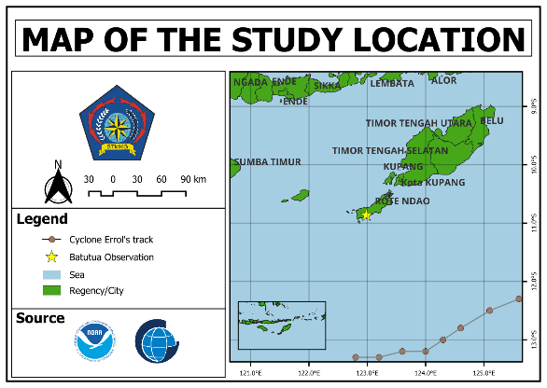
Figure 1. Map of the study location.
Data Sources and Collection
The research utilized secondary data sourced from official data providers. The datasets comprised tropical cyclone track data, atmospheric data, bathymetry data, tidal constituent data, and sea level observations. The best-track data for Tropical Cyclone Errol were acquired from the Australian Bureau of Meteorology, encompassing details on the cyclone's development, such as observation time, cyclone center position, maximum sustained wind speed, maximum wind gust, minimum central pressure, and cyclone category.

Atmospheric data from ERA5 were retrieved from the Copernicus Climate Data Store, with variables including the 10-m zonal and meridional wind components and mean sea level pressure. The ERA5 data possess a spatial resolution of approximately 0.25° × 0.25°. Additionally, atmospheric data from the Final Operational Global Analysis were obtained via the UCAR GDEX portal, consisting of surface wind and sea level pressure data. These atmospheric variables served as forcing for the Delft3D-FLOW simulations.
Bathymetry data were employed to represent seabed conditions within the Delft3D-FLOW model domain. Tidal constituent data were sourced from the TPXO global tidal model to establish tidal boundary conditions. The tidal constituents included M2, S2, N2, K2, K1, O1, P1, Q1, M4, MS4, and MN4. Sea level observation data were collected from the Batutua Sea Level Observation Station on Rote Island and utilized as reference data for model validation.
Delft3D-FLOW Model Configuration
Storm surge simulations were conducted utilizing the Delft3D-FLOW hydrodynamic model. Tidal constituent data sourced from TPXO served as tidal boundary conditions at the model domain's open boundaries. Atmospheric forcing was characterized by spatially varying wind and pressure fields, which were independently derived from ERA5 and Final Operational Global Analysis data. These atmospheric data were processed into formats compatible with Delft3D-FLOW prior to their application in the model. The primary model parameters employed in the simulations are detailed in Table 1.
Table 1. Parameter Configuration
No. | Parameter | Description
1. | Physical | Wind
2. | Initial Condition | Uniform values
3. | Roughness Formula | Chezy
4. | Wind | Space varying wind and pressure
5. | Interval | 60 min
6. | History interval | 1 min
Simulations were executed with consistent model domains, grids, tidal boundary conditions, and model parameters to ensure that any variations in results were predominantly attributable to the atmospheric forcing datasets. The simulation period spanned from 9 to 18 April 2025. The original model configuration employed a 1-minute computational time step, incorporating wind and tidal forces as physical processes, alongside uniform initial water level conditions.
Simulation Scenarios and Storm Surge Calculation
Three distinct simulation scenarios were executed. The initial scenario involved a tide-only simulation, employing solely tidal constituents to determine the astronomical sea level. The second scenario incorporated the same tidal forcing in conjunction with ERA5 atmospheric forcing, whereas the third scenario combined the same tidal forcing with Final Operational Global Analysis atmospheric forcing. All simulations maintained consistent model domains, grids, boundary conditions, and numerical configurations. The storm surge component was derived by subtracting the sea level from the tide-only simulation from that obtained in the atmospheric-forced simulation. This methodology effectively isolates the sea level component attributable to meteorological forcing. The storm surge was calculated using:
$$SS=η_{atm}-η_{tides}$$
Descrption:
$SS$ = storm surge (m);
$η_{atm}$ = simulated sea level with atmospheric forcing (m);
$η_{tides}$ = simulated sea level without atmospheric forcing (m).
The analysis of the resulting storm surge values was conducted both temporally and spatially. Temporal analysis focused on the observation location, whereas spatial analysis examined the distribution and evolution of the storm surge across the study area.
Model Validation
Model validation involved a comparison between simulated sea levels from the ERA5 and Final Operational Global Analysis scenarios and observed sea level data from Batutua Station, spanning the period from 9 to 18 April 2025. This validation focused on sea level data due to the unavailability of direct storm surge observations at the study site. Two statistical parameters were employed to assess model performance: the Root Mean Square Error (RMSE) and the correlation coefficient. The RMSE quantifies the magnitude of discrepancies between simulated and observed sea levels, with lower values signifying improved agreement. The RMSE was computed as follows:
$$RMSE=\sqrt{\frac{1}{n}\sum_{i=1}^{n}{{\left(X_{i}-Y_{i}\right)}^{2}}}$$
Description:
$X_{i}$ is the simulated sea level
$Y_{i}$ is the observed sea level, and n is the number of observations.
The correlation coefficient was used to evaluate the strength and direction of the linear relationship between the simulated and observed sea level variations:
$$r=\frac{\sum_{i=1}^{n}{\left(X_{i}-\overline{X}\right)\left(Y_{i}-\overline{Y}\right)}}{\sqrt{\sum_{i=1}^{n}{{\left(X_{i}-\overline{X}\right)}^{2}}\sum_{i=1}^{n}{{\left(Y_{i}-\overline{Y}\right)}^{2}}}}$$
Description:
$r$ is the correlation coefficient,
$\overline{X}$ is the mean simulated sea level,
$\overline{Y}$ is the mean observed sea level.
A correlation coefficient nearing 1 signifies a strong positive relationship between the simulated and observed variations, while a value nearing −1 signifies a strong negative relationship. Conversely, a value close to 0 denotes a weak or negligible linear relationship. The validation results were subsequently employed to compare the performance of ERA5 and Final Operational Global Analysis atmospheric forcing in replicating the observed sea level variations during Tropical Cyclone Errol.
RESULTS AND DISCUSSION
Tropical Cyclone Errol was first detected as a tropical low-pressure system over the Arafura Sea on 9 April 2025. Between 9 and 18 April 2025, the system progressed southwestward toward the Indian Ocean, subsequently altering its course southeastward and gradually diminishing in strength. Although the Batutua observation site was situated north of the cyclone's primary trajectory, the atmospheric circulation associated with the cyclone nonetheless affected the adjacent waters.
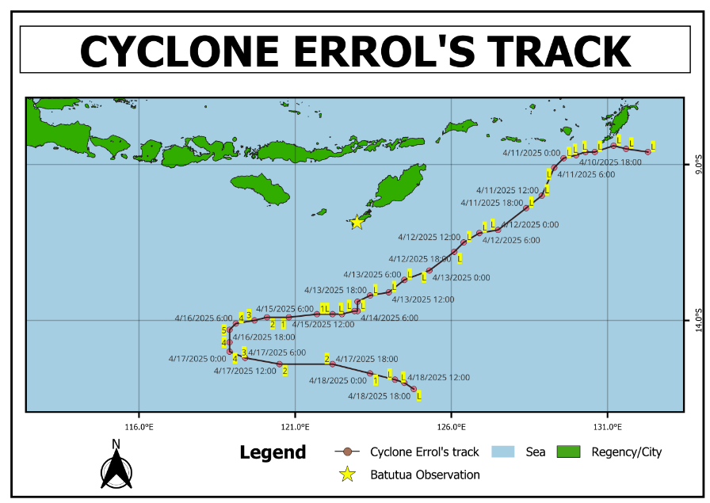
Figure 2. Cyclone Errol’s Track
Between 9 and 14 April, the system persisted in a tropical low phase, exhibiting relatively weak intensity. On 15 April, it evolved into Tropical Cyclone Errol and experienced rapid intensification, attaining its peak intensity on 16 April. Subsequently, the system progressed southeastward and gradually weakened by 18 April. These alterations in cyclone position and intensity influenced the wind and atmospheric pressure fields over the adjacent waters, potentially impacting sea level variations around Batutua.
Sea Level Analysis and Model Validation
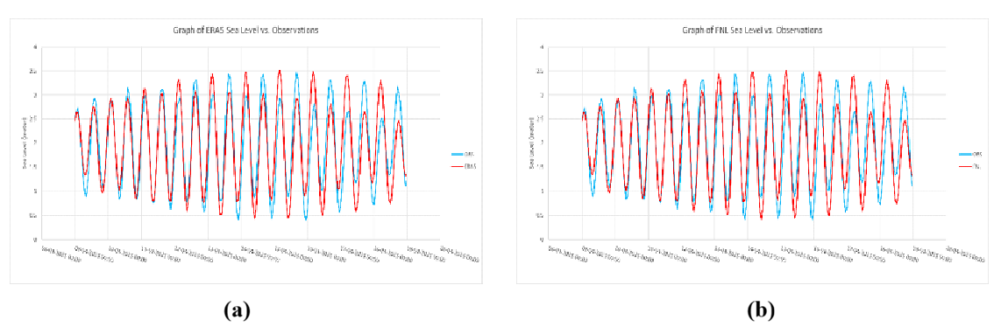
Figure 3. (a) Sea-level height graph from the ERA5 model and observations, (b) Sea-level height graph from the FNL model and observations
The simulated sea level, derived from both ERA5 and Final Operational Global Analysis atmospheric forcing, effectively replicated the observed temporal fluctuations at Batutua Station during the period of 9–18 April 2025. The synchronization of high and low water levels with the observations suggests that Delft3D-FLOW accurately represented the tidal phase. From 9–11 April, there was a notable concordance between the simulated and observed sea levels in terms of both phase and amplitude. However, from 12 April onwards, discrepancies in amplitude became more pronounced, coinciding with the intensification of Tropical Cyclone Errol. These discrepancies may be attributed to challenges in accurately representing local atmospheric variability and coastal hydrodynamic processes.
The simulation utilizing Final Operational Global Analysis demonstrated performance comparable to that of the ERA5 simulation. Both simulations exhibited a similar pattern of tidal fluctuations, although deviations in amplitude became more pronounced after 12 April. Overall, the two atmospheric forcing datasets yielded analogous temporal characteristics in sea level variations at Batutua.
Table 2. Validation Results
Validation
 | RMSE | Correlation
ERA5 | 0.4324 | 0.8676
FNL | 0.4322 | 0.8677
The statistical validation reveals that the ERA5 simulation yielded a Root Mean Square Error (RMSE) of 0.4324 m and a correlation coefficient of 0.8676, whereas the Final Operational Global Analysis simulation resulted in an RMSE of 0.4322 m and a correlation coefficient of 0.8677. These correlation coefficients demonstrate a very strong concordance between the simulated and observed sea level variations. The discrepancies between the two simulations were minimal, with a mere 0.0002 m difference in RMSE and 0.0001 in the correlation coefficient. The slightly lower RMSE from the Final Operational Global Analysis suggests a marginally reduced overall error in replicating the observed sea level. Additionally, the slightly higher correlation coefficient indicates that its temporal variations were marginally more aligned with the observations compared to those simulated using ERA5. Nonetheless, the negligible differences in both statistical metrics imply that neither atmospheric dataset offers a significant advantage over the other in terms of sea level reproduction at Batutua. This finding suggests that the choice between ERA5 and Final Operational Global Analysis exerts limited influence on the accuracy of simulated sea levels at the Batutua observation site. Consequently, both atmospheric datasets exhibited nearly identical performance in reproducing sea level variations at Batutua, with the Final Operational Global Analysis demonstrating a marginally superior statistical performance. Therefore, both datasets can be deemed suitable atmospheric forcing inputs for further storm surge analysis in the study area.
Temporal Analysis of Storm Surge
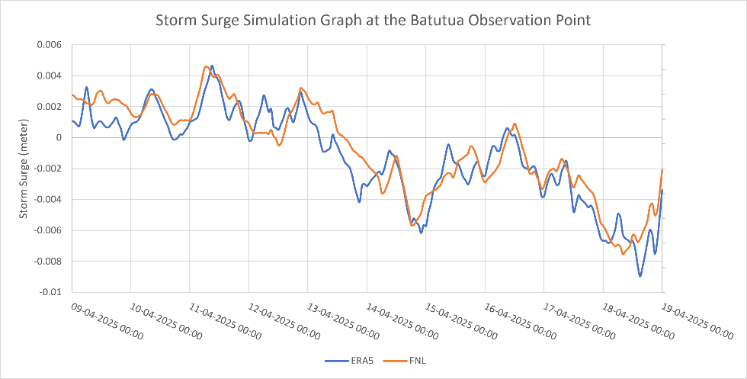
Figure 4. Storm surge graph at the Batutua observation station.
The time series of storm surge at Batutua exhibits a comparable temporal pattern for both ERA5 and Final Operational Global Analysis atmospheric forcing during the period of 9–18 April 2025. During 9–11 April, when the system remained in the tropical low phase, the storm surge was predominantly positive, ranging from approximately 0.001 to 0.0045 m, with the peak value recorded on 11 April. This suggests a relatively minor sea level rise associated with the initial development of the atmospheric disturbance.
From 12 to 14 April, the storm surge gradually diminished towards zero and transitioned into negative values as the system moved southwestward and intensified. During 15–18 April, when Tropical Cyclone Errol attained its peak intensity, the storm surge at Batutua was predominantly negative. This indicates that the magnitude of the storm surge was influenced not only by the cyclone's intensity but also by the relative position and movement of the cyclone center in relation to Batutua.
Overall, the ERA5 and Final Operational Global Analysis simulations yielded nearly identical temporal patterns, although differences in amplitude were noted. The transition from positive to negative storm surge aligned with the evolution and movement of Tropical Cyclone Errol, indicating that the atmospheric forcing impacted the temporal response of sea level at Batutua.
Spatial Distribution of Storm Surge
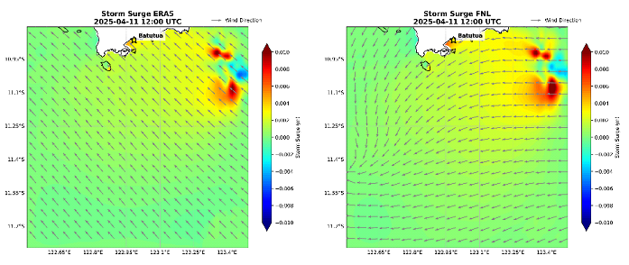
Figure 5. Spatial map of storm surge from ERA5 and FNL models on April 11, 2025.
The spatial distribution of storm surge exhibited a distinct transition throughout the development of Tropical Cyclone Errol. On 11 April 2025, simulations from both ERA5 and the Final Operational Global Analysis indicated predominantly positive storm surge across the study area. In the vicinity of Batutua, the storm surge measured approximately 0.002–0.004 m, whereas higher positive anomalies, reaching up to approximately 0.010 m, were detected in the eastern region of the domain. This pattern reflects the initial wind setup response during the early stages of the tropical disturbance's development. Although the spatial patterns generated by the two atmospheric datasets were largely similar, the Final Operational Global Analysis produced a slightly more extensive distribution of positive anomalies.
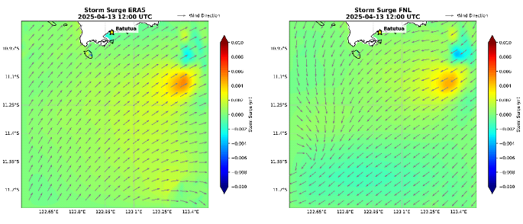
Figure 6. Spatial map of storm surge from ERA5 and FNL models on April 13, 2025.
On April 13, 2025, the spatial distribution transitioned from a positive to a negative storm surge. In the vicinity of Batutua, positive values diminished to approximately 0.001–0.002 m, while negative anomalies emerged, progressing from the southern to the central region of the domain. Both simulations exhibited comparable spatial patterns, suggesting that the altered position and intensified strength of Tropical Cyclone Errol were linked to a shift in the sea level response.
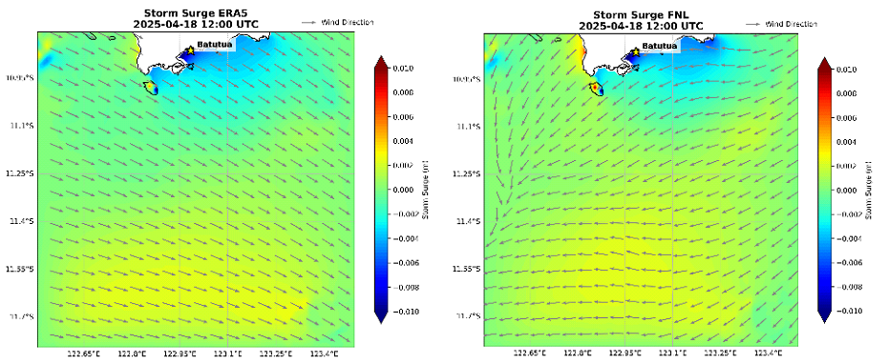
Figure 7. Spatial map of storm surge from ERA5 and FNL models on April 18, 2025.
By April 18, 2025, the negative storm surge had significantly expanded throughout the study area. This negative anomaly encompassed a substantial portion of the southern coastal waters of Rote Island, whereas positive storm surge was confined to a few areas. The ERA5 simulation indicated a more pronounced and extensive negative anomaly compared to the Final Operational Global Analysis, especially in the vicinity of Batutua. This observation aligns with the temporal analysis, which demonstrated a continued decrease in storm surge towards the conclusion of the simulation period. Despite variations in magnitude, both atmospheric forcing datasets exhibited a similar spatial distribution of negative storm surge across the study area.

CONCLUSION
The Delft3D-FLOW simulations effectively captured the temporal and spatial dynamics of sea level and storm surge associated with Tropical Cyclone Errol around Rote Island from 9 to 18 April 2025. Both the ERA5 and Final Operational Global Analysis atmospheric forcings yielded similar sea level fluctuations and spatial storm surge patterns. Validation of the model against observations from Batutua Station revealed a Root Mean Square Error of 0.4324 m and a correlation coefficient of 0.8676 for ERA5, while the Final Operational Global Analysis produced values of 0.4322 m and 0.8677, respectively. These findings suggest that both atmospheric datasets performed comparably in representing observed sea level variations.
The spatial analysis indicated that the storm surge transitioned from predominantly positive conditions, characterized by wind setup on 11 April, to a transitional state on 13 April, and ultimately to predominantly negative storm surge or set-down by 18 April as Tropical Cyclone Errol progressed relative to the study area. Despite observed differences in magnitude, both ERA5 and Final Operational Global Analysis produced generally similar spatial patterns, underscoring their comparable efficacy in representing the storm surge response during the cyclone event.
REFERENCES
Arqam, M., L. Anadi dan Nadia, Loar. (2019). Struktur Komunitas Ikan Karang pada Lokasi Rehabilitasi Karang Modul Bioreeftek di Perairan Desa Tanjung Tiram, Kabupaten Konawe Selatan. Jurnal Manajemen Sumber daya Perairan. 4 (3), 214-221.
English, et.al. 1994. Survey Manual for Tropical Marine Resources. Australian Institute of Marine Science, Townsville.
Fazillah, M. R., Afrian, T., Razi, N. M., Ulfah, M. U., & Bahri, S. (2020). Kelimpahan, Keanekaragaman dan Biomasa Ikan Karang Pada Perairan Ujong Pancu, Kabupaten Aceh Besar. Jurnal Perikanan Tropis, 7(2), 134-144.
Https://reefguide.org/search.html
Maulana, R. (2022). Struktur Komunitas Ikan Karang Berdasarkan Peranannya Pada Area Transplantasi Terumbu Karang di Kawasan Taman Wisata Perairan Kapoposang, Kabupaten Pangkajene Kepulauan Sulawesi Selatan= Community Structure of Reef Fish in The Coral Reef Transplant Area In Aquatic Park Area of Kapoposang Island, Pangkajene and Island Regency, South Sulawesi (Doctoral Dissertation, Universitas Hasanuddin).
Mujiyanto., & Satria, F. (2013) Sebaran Jenis-Jenis Ikan Famili Labridae (Wrasess) Di Taman Nasional Karimunjawa, Jawa Tengah. Jurnal. Balai Penelitian Pemulihan dan Konservasi Sumberdaya Ikan.
Nurhasinta, N., Umroh, U., & Syari, I. A. (2019). Kelimpahan ikan Chaetodontidae dan Pomacentridae di ekosistem terumbu karang Pulau Ketawai dan Pulau Gusung Asam Kabupaten Bangka Tengah. Maspari Journal: Marine Science Research, 11(2), 97-114.
Nurjirana, N., & Burhanuddin, A. I. (2017). Kelimpahan dan keragaman jenis ikan Famili Chaetodontidae berdasarkan kondisi tutupan karang hidup di Kepulauan Spermonde Sulawesi Selatan, Jurnal Ilmu Kelautan Spermonde, 3(2).
Paembonan, R. E., Naipon, Y. D., Baddu, S., Baksir, A., Marus, I., Ramili, Y.,& Akbar, N. (2022). Penilaian Ikan Karang Pada Daerah Transplantasi Karang di Perairan Laut Kastela Ternate. Jurnal Ilmu Kelautan Kepulauan, 5(1).
Puspasari, R., Rahmadi, P., Rahmawati, P. F., & Samu-Samu, A. S. (2015). Interaksi Variabilitas Iklim Dengan Ekosistem Terumbu Karang Dan Sumber Daya Ikan Karang. Jurnal Penelitian Perikanan Indonesia, 21(4), 211-220.
Rondonuwu, A. B. (2014). Ikan karang di wilayah terumbu karang kecamatan maba kabupaten halmahera timur provinsi maluku utara. Jurnal Ilmiah Platax, 2(1).
Sasauw, H., Bataragoa, N. E., Manu, G. D., Rondonuwu, A. B., Lalita, J. D., & Kusen, J. D. (2022). Acanthuridae in Bitunuris Waters Talaud Islands. Jurnal Ilmiah PLATAX, 10(2), 261-268.
Setiawan, F. (2010). Panduan lapangan identifikasi ikan karang dan invertebrate laut. Wildlife Conservation Society, Manado.
Suryono, S., Ambariyanto, A., Munasik, M., Ario, R., Pratikto, I., Taufiq-SPJ, N., & Supryhatun, E. (2022). Perubahan Luas Terumbu Karang di Pulau Panjang, Jepara. Jurnal Kelautan Tropis, 25(3), 337-344.
Syahrul, M. (2022). Keterkaitan Kondisi Terumbu Karang Dengan Sebaran dan Keanekaragaman Fauna Megabentos di Perairan Pulau Barranglompo Kota Makassar (Doctoral dissertation, Universitas Hasanuddin).
Titaheluw, S. S., Kamal, M. M., & Ernawati, Y. (2015). Hubungan antara ikan Chaetodontidae dengan bentuk pertumbuhan karang. Agrikan: Jurnal Agribisnis Perikanan,8(1), 77-86.
Umar, J. (2020). Komunitas Ikan Karang di Daerah Transplantasi Karang dan Di Daerah Terumbu Karang Alami (Studi Kasus Di Perairan Desa Botutonuo Kabupaten Bone Bolango Provinsi Gorontalo). Skripsi,1(633414067).
Yanuar, A., & Aunurohim, A. (2015). Komunitas Ikan Karang Pada Tiga Model Terumbu Buatan (Artificial Reef) di Perairan Pasir Putih Situbondo, Jawa Timur. Jurnal Sains dan Seni ITS, 4(1), E19-E24.

